## Integrating PowerApps with External Systems

**Lab Time**: 60 minutes

**Lab Folder**: C:\Student\Modules\08_ExternalSystems\Lab

**Lab Overview**: In this lab you will begin by creating a flow which uses the HTTP connector to retrieve data from an external web service. Next, you will learn to use the HTTP connector in order to execute a child flow from a parent flow. In the final exercise, you will create a custom connector which makes it possible for a canvas app to retrieve customer data directly from an external web service.

### Exercise 1: Use the HTTP Connector to Retrieve Data from an External Web Service

In this exercise, you will use the HTTP connector to call an OData web service and to parse the JSON result returned by the web service.

1. Configure Chrome with the JSON Viewer extension.
   1. In Chrome, navigate to the following URL to install the **JSON Viewer** extension.

<https://chrome.google.com/webstore/detail/json-viewer/aimiinbnnkboelefkjlenlgimcabobli>

* 1. Click the **Add to Chrome** button to install the extension.

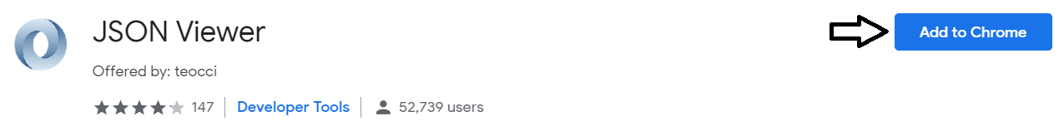

* 1. The JSON Viewer Chrome extension should now installed and active.

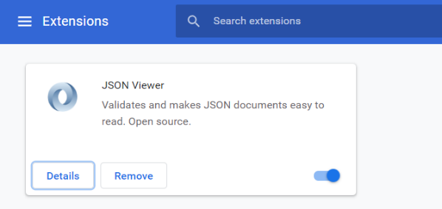

The are several different JSON viewer extensions available for Chrome. You don't have to install this Chrome extension if you've already installed one of the other extension which provide a JSON viewer or formatter.

1. Inspect the web service API available at <http://subliminalsystems.com>.
   1. Click [here](http://subliminalsystems.com/api/Customers/?$select=LastName,FirstName,CustomerId) to navigate to the following URL in Chrome.

http://subliminalsystems.com/api/Customers/?$select=LastName,FirstName,CustomerId

* 1. Chrome should display the JSON result returned by the web service at **http://subliminalsystems.com**.

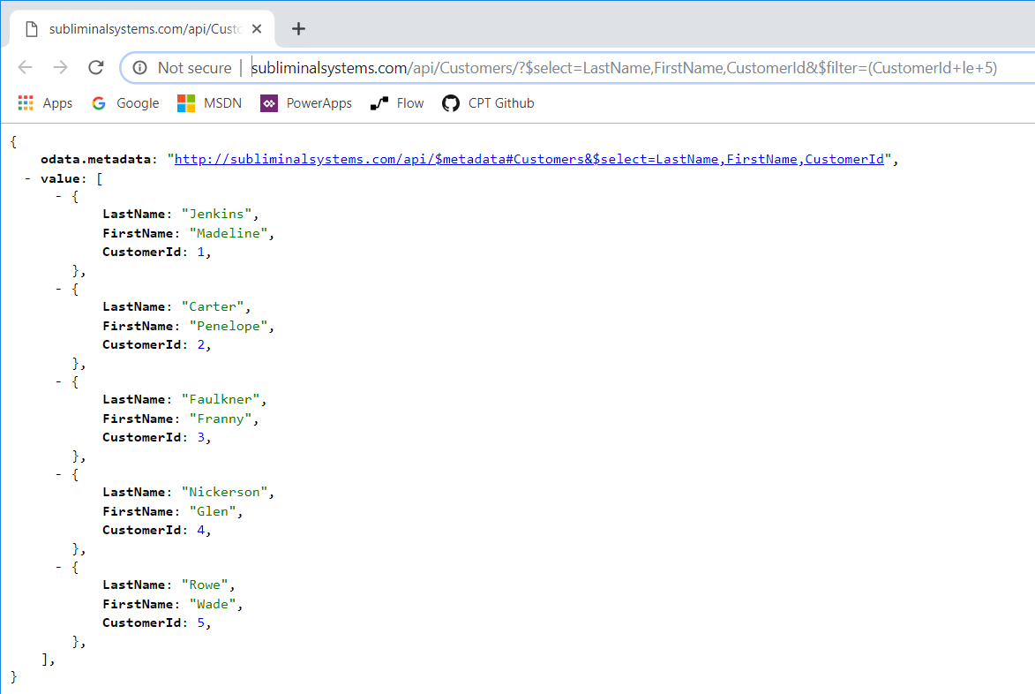

* 1. Click [here](http://subliminalsystems.com/api/Customers(10)) to navigate to the following URL.

http://subliminalsystems.com/api/Customers(10)

This URL follows the OData pattern for retrieving a single instance using a collection name followed by the instance ID in parenthesis.

* 1. You should see the JSON result for a single customer displayed by the Chrome browser.

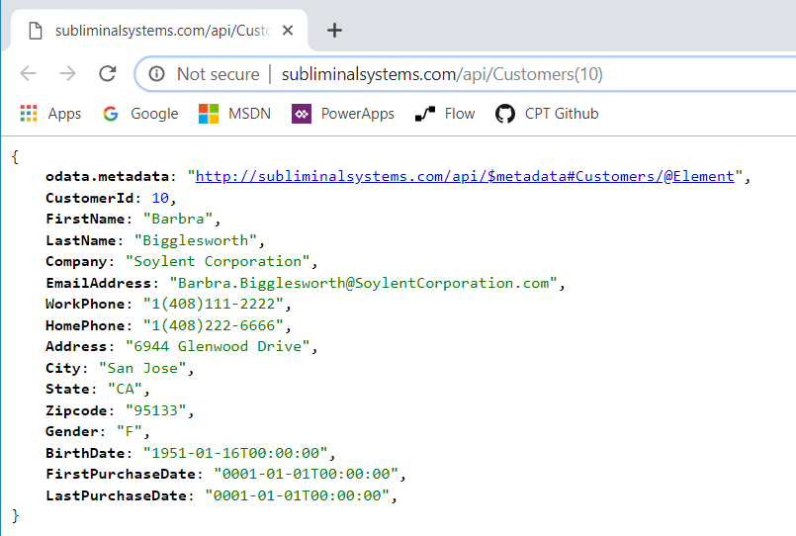

When calling a web service in the real world, it's likely that the web service will be secured and you will have to do additional work to authenticate with the web service when executing HTTP requests. In this exercise you will work with a public web service that is accessible using anonymous access. This lab includes this simplification so you can focus on creating the OData URL to call the web service and on parsing the JSON result returned from the web service in the HTTP response.

1. Create a new flow named **Add New Customer**.
   1. In the browser, navigate to the Flow Portal at [https://flow.microsoft.com](https://flow.microsoft.com/).
   2. Click the **My flows** link on the left.
   3. Execute the **+ New > + Create from blank** command to create a new flow.

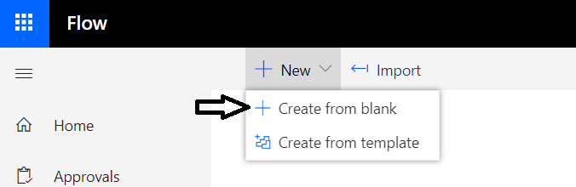

* 1. Click **Create from blank** to continue.

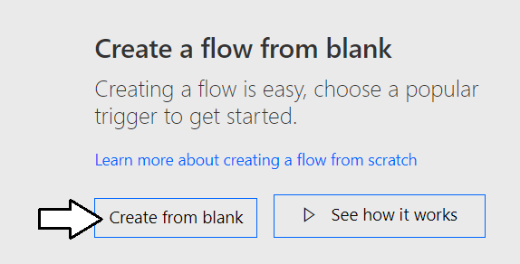

* 1. Once the flow has been created, update the name of the flow to **Add New Customer**.

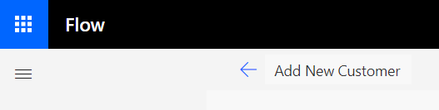

* 1. When looking for a trigger, type **button** into the search box.

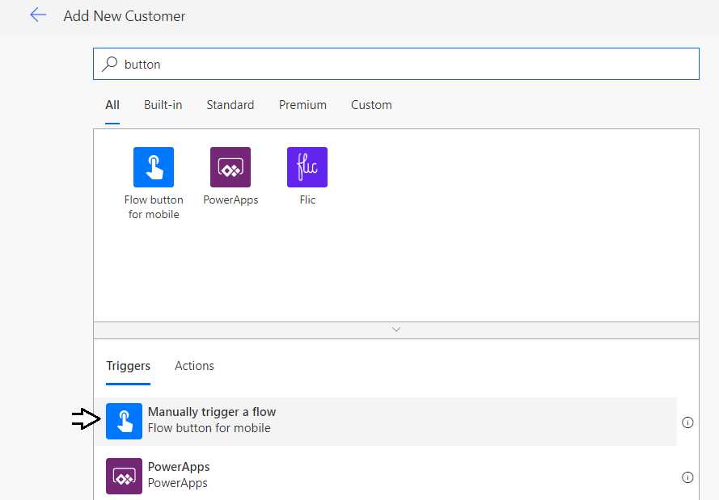

* 1. Select the **Manually trigger a flow** trigger.



* 1. After adding the **Manually trigger a flow** trigger, click **New Step** to add a new step.

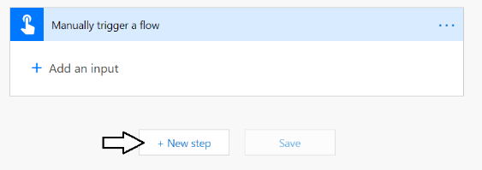

* 1. Type **Compose** into the search box and then select the action named **Compose**.

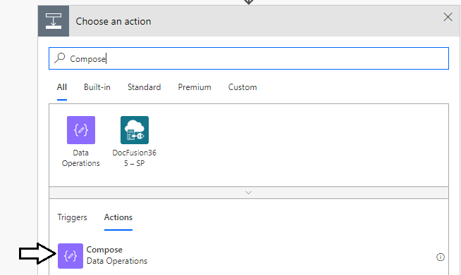

* 1. Rename the **Compose** action to **REST URL for new Customer**.

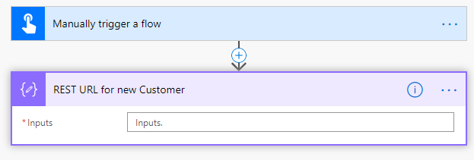

* 1. Copy the following WDL expression to the clipboard so you can paste it into the Compose action in the next step.

concat('http://subliminalsystems.com/api/Customers(', rand(1,300), ')')

This WDL expression creates a random number between 1 and 300 and then generates a URL with this number as the customer ID.

* 1. Select the **Inputs** parameter for **REST URL for new Customer** action.
  2. Click the **Expressions** link to enter an expression.
  3. Paste the expression from the clipboard and then click **OK** to enter the expression for the **Inputs** parameter

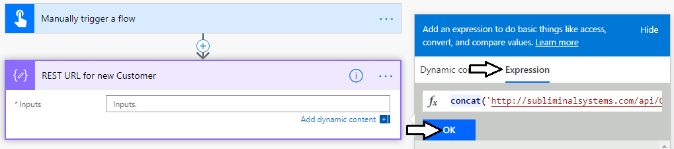

* 1. You should be able to see your expression has been accepted for the **Inputs** parameter.

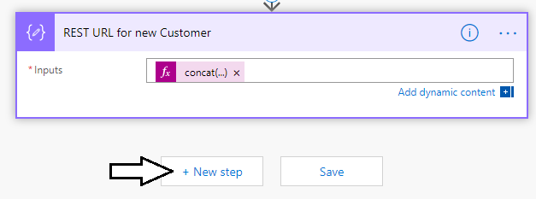

1. Add an HTTP action to call to the web service and retrieve customer data.
   1. Click **New Step** to add new action below the **REST URL for new Customer** action.
   2. Type **HTTP** into the search textbox.
   3. Select the **HTTP** action from the **Actions** list.

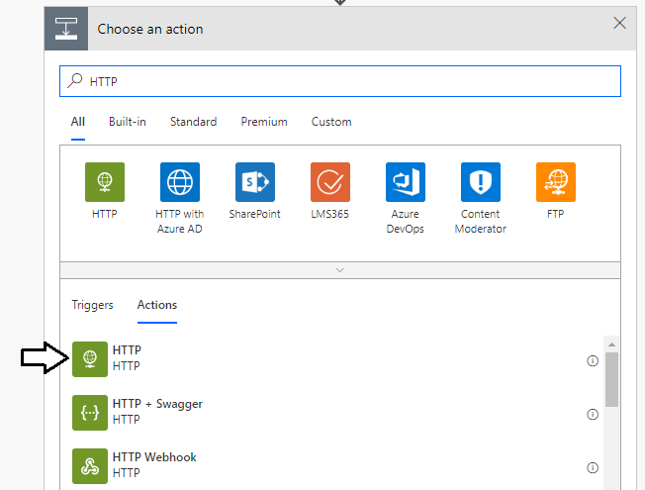

* 1. Update the **Method** input parameter to **GET**.

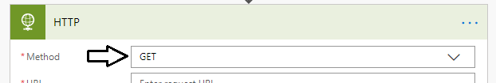

* 1. Update the **URI** parameter with the **Output** parameter from the **REST URL for new Customer** action.

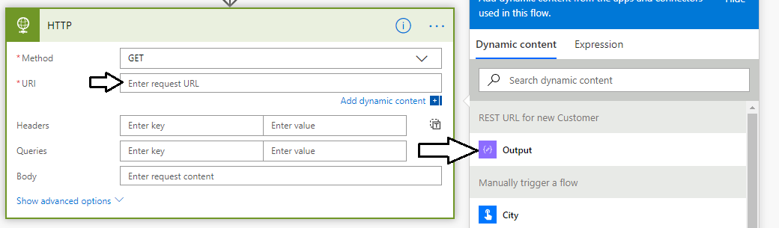

* 1. Once you have updated the two parameters **Method** and **URI**, you have completed the work required for the **HTTP** action.

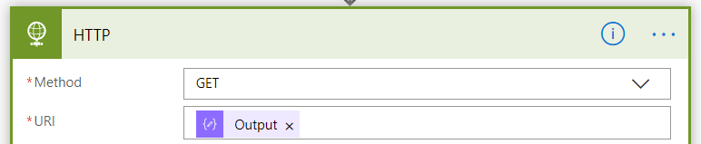

* 1. Save your work by clicking the Save button in the upper right corner.



1. Test the flow to ensure the HTTP action works properly.
   1. Click the **Test** button in the upper right corner.



* 1. Select the **I'll perform the trigger action** option and then click **Test**.

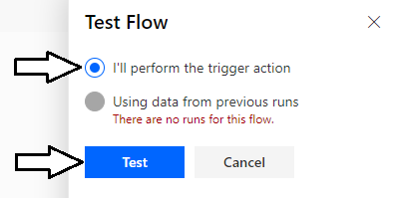

* 1. When prompted with the **Run flow** dialog, click the **Run flow** button to continue.

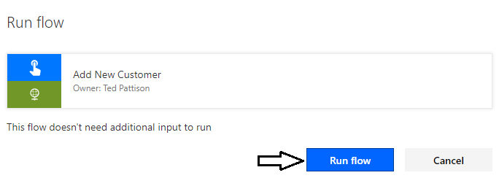

* 1. You should see a dialog indicating the flow has started successfully. Click **Done** to continue.

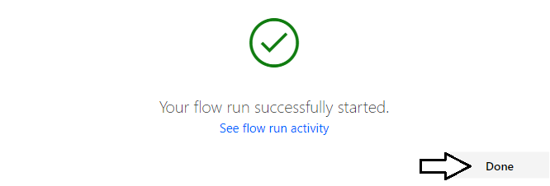

* 1. You should new see the run history page for your test run. All actions should have completed successfully.

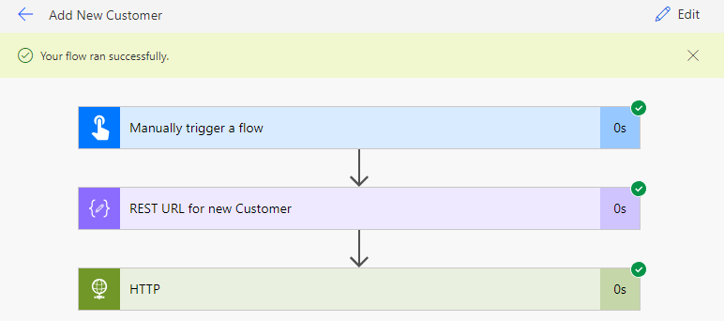

* 1. Click on the **REST URL for new Customer** action and inspect its **Outputs** parameter value to see the URL that was used.

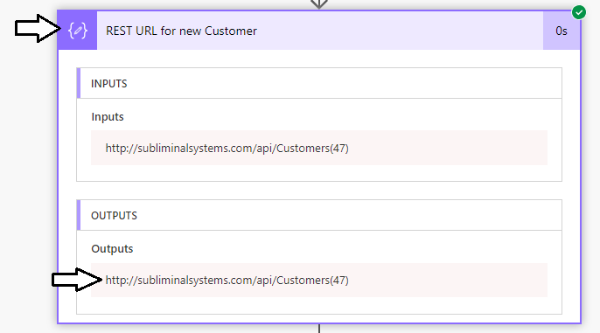

* 1. Next, click on the HTTP action to inspect its parameter values.

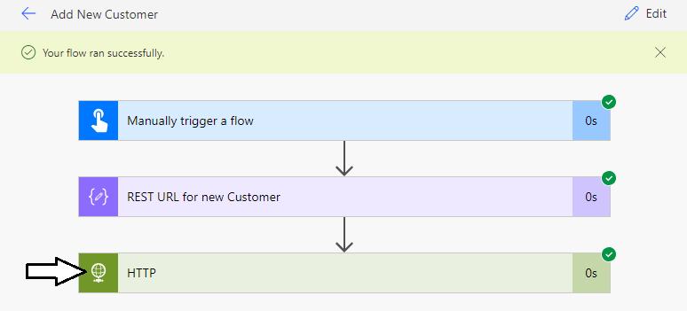

* 1. Inspect the **Body** parameter to see the actual JSON content returned by the web service in the HTTP response.

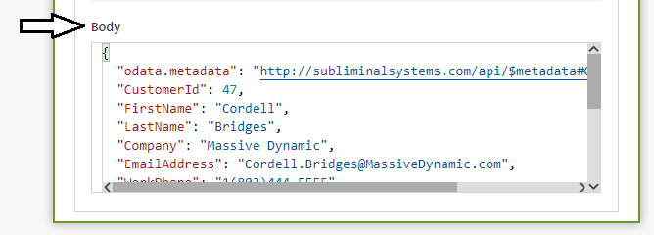

You have now reached the point where your flow is retrieving customer data from a web service. However, you flow is not yet doing anything with the customer data. Over the next few steps you will add a few more actions to parse the JSON result and add a new customer item into a SharePoint list.

1. Add a new step to parse the JSON returned by the web service.
   1. Click the **Edit** button in the upper right corner to return to edit mode with the flow name **Add New Customer flow**.

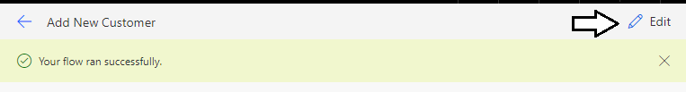

* 1. Click **New Step** to add a new action below the **HTTP** action.

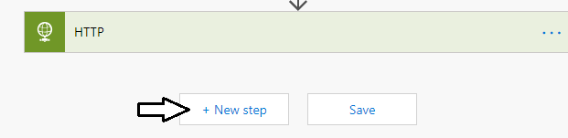

* 1. Type **JSON** into the search box and then select the **Parse JSON** action.

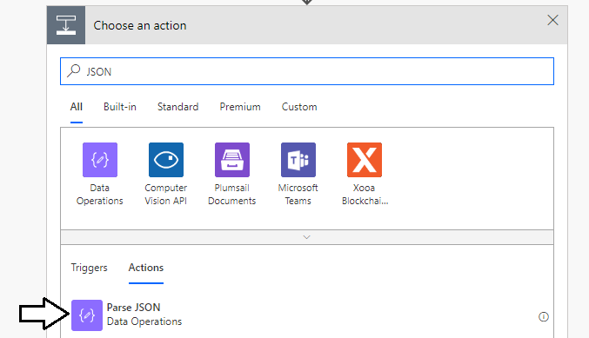

* 1. The action will be created with a name of Parse JSON. Click the action's context menu and select the **Rename** command.



* 1. Rename the Parse JSON action to **Customer Data**.

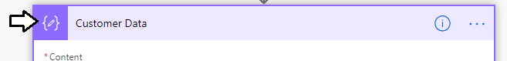

* 1. Update the **Content** input parameter of **Customer Data** with the **Body** output parameter of the **HTTP** action.

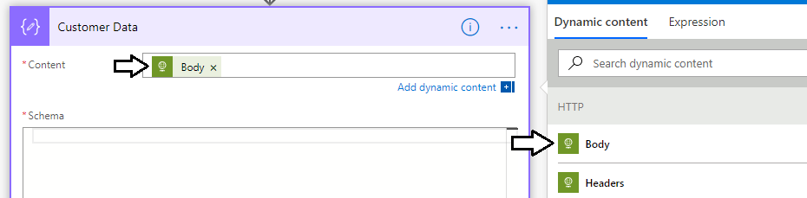

* 1. Click on the **Use sample payload to generate schema** link at the bottom of the **Customer Data** action.

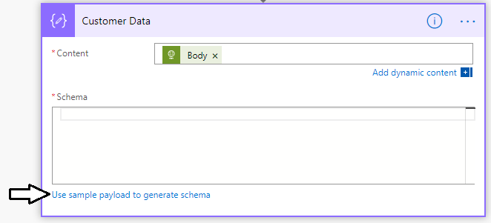

* 1. You should be prompted with the **Enter or paste a sample JSON payload** dialog as shown in the following screenshot.

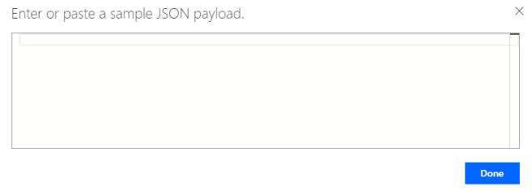

* 1. Copy the following JSON content with customer data into the clipboard.

{

"CustomerId": 47,

"FirstName": "Cordell",

"LastName": "Bridges",

"Company": "Massive Dynamic",

"EmailAddress": "Cordell.Bridges@MassiveDynamic.com",

"WorkPhone": "1(803)444-5555",

"HomePhone": "1(803)111-8888",

"Address": "2019 Power Platform Avenue",

"City": "Tampa",

"State": "FL",

"Zipcode": "11111"

}

* 1. Paste the contents of the clipboard into the **Enter or paste a sample JSON payload** dialog and then click **Done**.

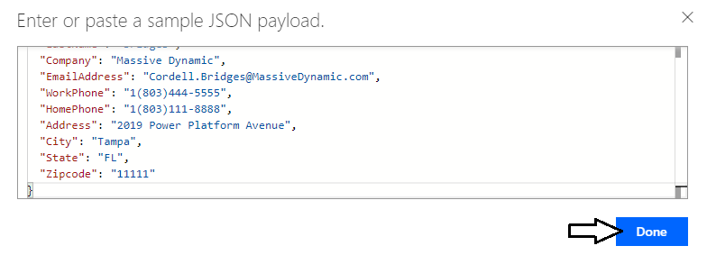

* 1. Once you've provided the sample JSON data, you should be able to see a new schema has been automatically generated.

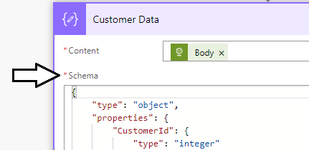

Now that you have added an action to parse the JSON result with the customer data, you are now ready to add the final action to your flow which will create a new SharePoint list item using the customer data returned from the web service.

This lab assumes you have completed the earlier PowerApps labs and you have a SharePoint Online site in which you have already created a list named **Customers**. If you have not already created the **Customers** list, you should return to **Lab 2: Building a Data-driven Canvas App** and complete **Exercise 1: Create a SharePoint List to Store Customer Data**.

1. Add a new action to create a new SharePoint list item using the customer data.
   1. Click **New Step** to add a new action below the **Customer Data** action.

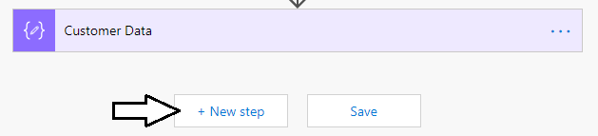

* 1. Type **SharePoint Create Item** into the search box and then select the **Create Item** action from the **SharePoint** connector.

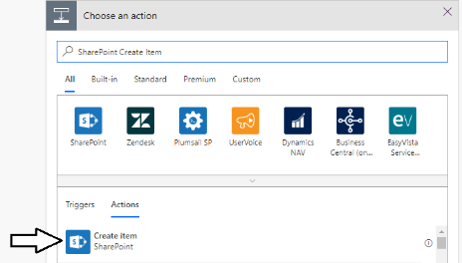

* 1. Update the parameters named **Site Address** and **List Name** to reference the **Customers** list you created in an earlier lab.

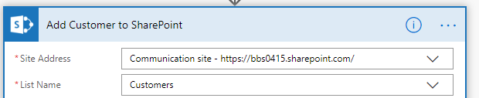

* 1. Map all the fields from the Customer Data action to columns in the SharePoint list as shown in the following screenshot.

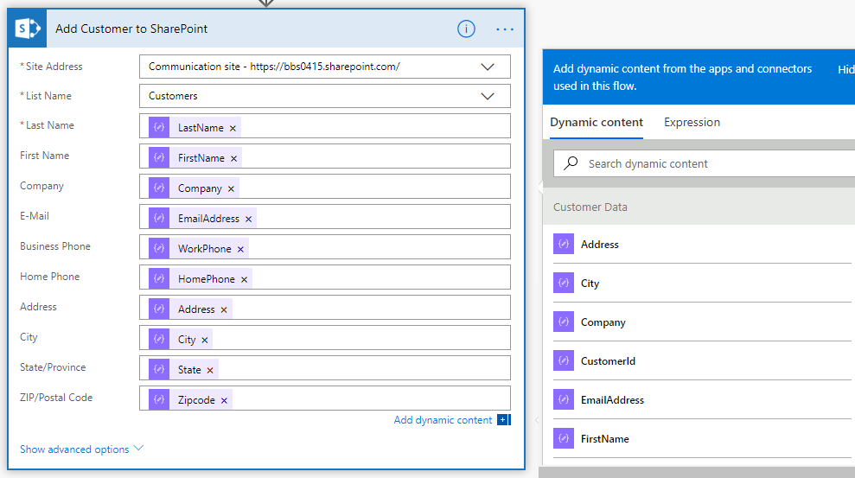

* 1. Save your changes by clicking the Save button in the upper right corner.

1. Test your work.
   1. Click Test in the upper right corner to start a test run of your flow.
   2. When prompted with the **Run flow** dialog, click **Continue** to grant access to the **SharePoint** connector.

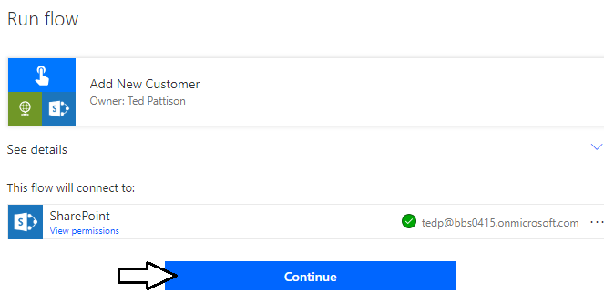

* 1. Click **Run flow** to begin the test run.

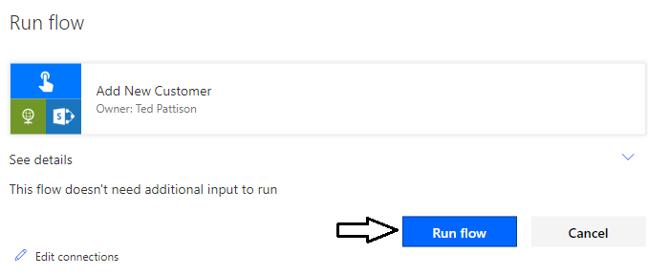

* 1. When you see the dialog indicating your flow has started successfully, click **Done**.

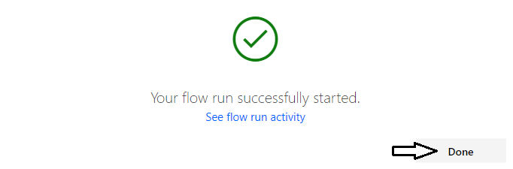

* 1. Examine the run history and verify that all actions completed successfully including the **Add Customer to SharePoint** action.

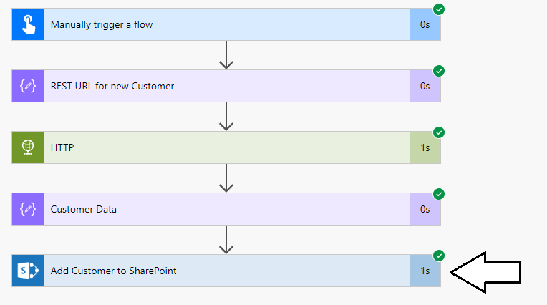

1. Run the flow outside the flow editing environment.
   1. Return to the **My flows** list in the Flow portal.

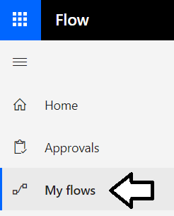

* 1. Locate the **Add New Customer** flow and click the **Run Now** button to run it on demand.

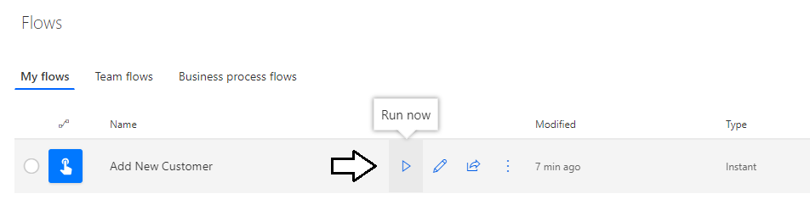

* 1. Click the **Run Now** button a second time to run the flow again.
  2. Click on **Add New Customer** to view the **RUN HISTORY** list for the **Add New Customer** flow.

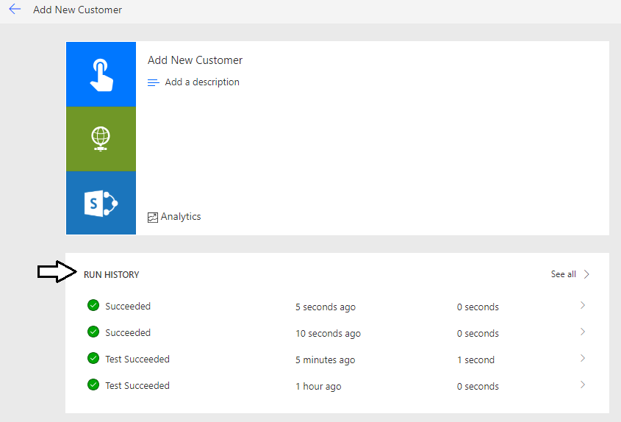

Note that the **RUN HISTORY** list indicates which runs were test runs and which were normal runs.

* 1. Navigate to the Customer list in your SharePoint Online site and verify that new customers have been added.

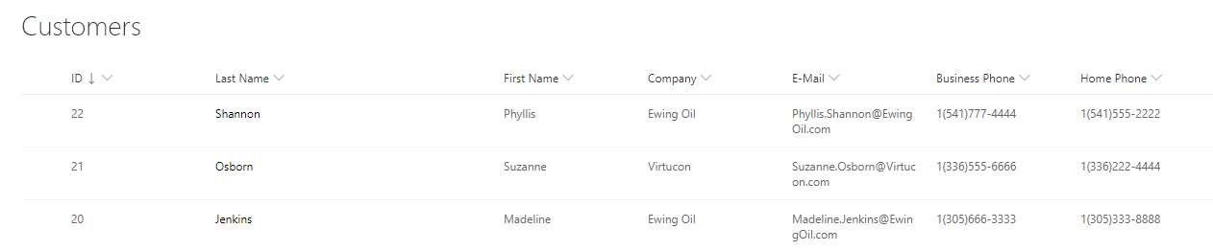

### Exercise 2: Execute a Child Flow from a Parent Flow

In this exercise, you will trigger a child flow from a parent flow using the HTTP connector.

1. Clone the **Add New Customer** flow using the **Save As** command.
   1. Return to the **My flows** list in the Flow portal.
   2. Dropdown the context menu for the **Add New Customer** flow and select the **Save As** command.

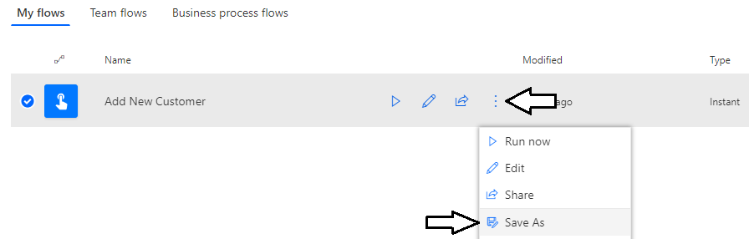

* 1. In the **Create a copy of this flow** dialog, give the new flow a name of **Add New Customer with HTTP trigger**.

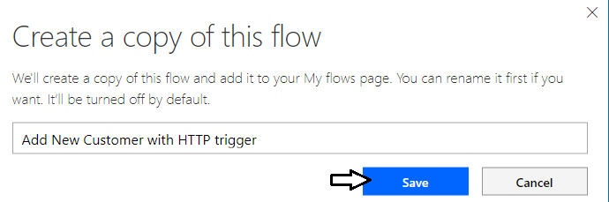

* 1. When the new flow is created, you will notices that it is in a disabled state.

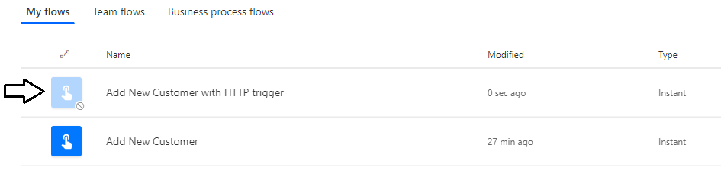

* 1. Dropdown the context menu for the **Add New Customer with HTTP trigger** flow and select the **Turn flow on** command.

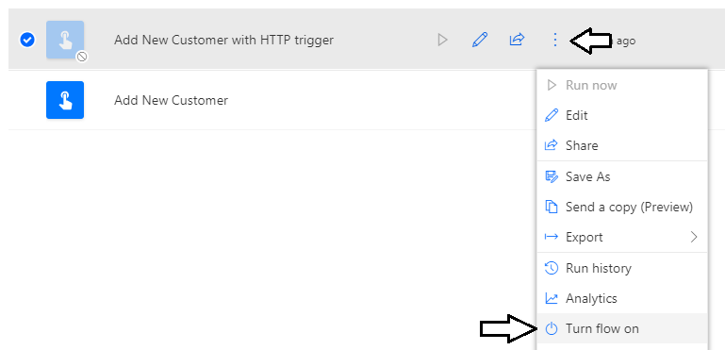

1. Replace the button trigger in the flow with an HTTP trigger.
   1. Click the pen icon to enter edit mode.



* 1. Use the dropdown context menu to delete the trigger named **Manually trigger a flow**.

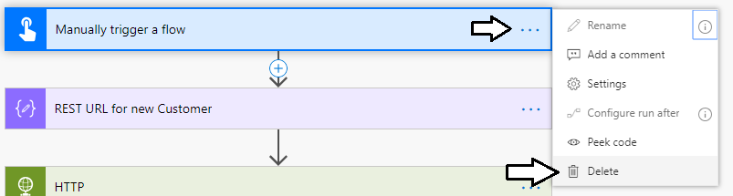

* 1. Click **OK** to confirm you want to delete the step for the trigger,

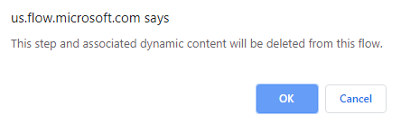

* 1. Search for a new trigger by typing **HTTP request** into the search box.
  2. Select the trigger named **When a HTTP request is received**.

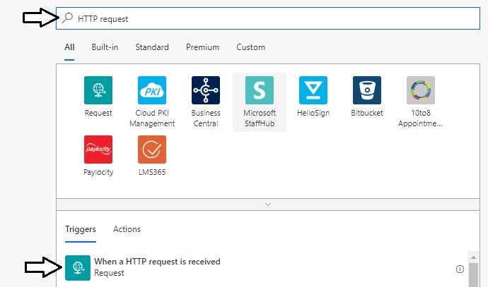

* 1. You cannot edit the **HTTP POST URL** parameter. Instead, its value is generated automatically when the flow is first saved.

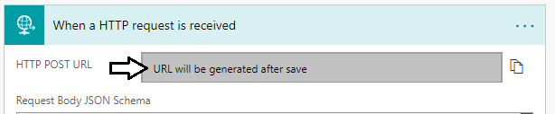

* 1. Click on the **Show advanced options** link.

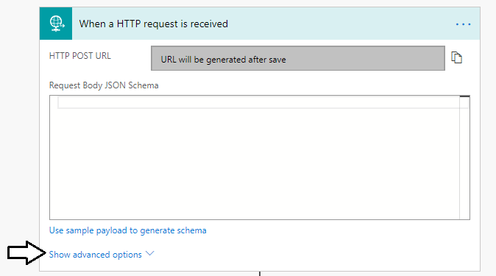

* 1. Set the **method** parameter to **GET** as shown in the following screenshot.

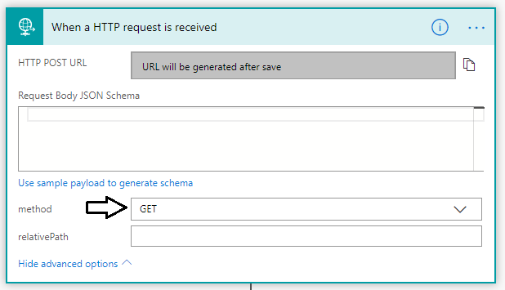

* 1. Click the **Save** button in the upper right corner to save the flow.

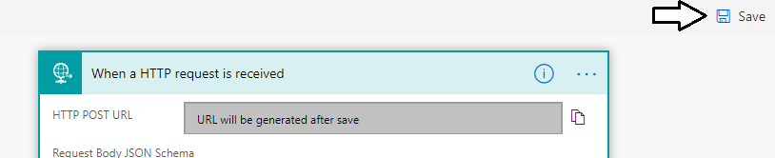

* 1. After the flow has been saved, you should see a new value appear for the **HTTP GET URL** parameter.
  2. Click the button to the right of the **HTTP GET URL** input control to copy the URL to the clipboard.

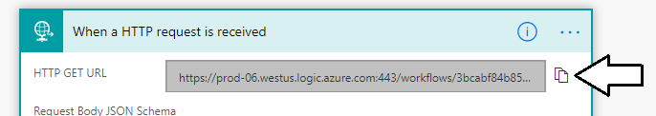

* 1. Open a text editor such as Notepad and paste in the URL. You will need to copy and paste this URL in an upcoming step.

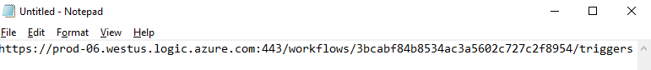

You have now completed the changes you need to make to the **Add New Customer with HTTP trigger** flow. Next, you will test it out by submitting a few HTTP requests through the browser.

* 1. Click the back arrow in the upper left to leave the flow editor and navigate to the page with the flow's **RUN HISTORY** list.



* 1. At this point, the RUN HISTORY list should be empty.

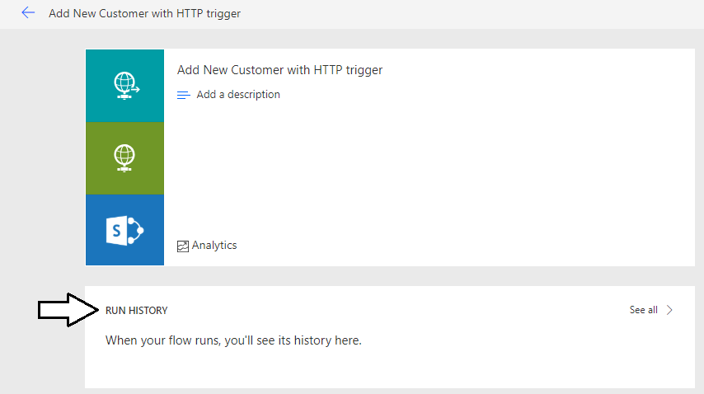

* 1. Launch a browser and then copy and paste the URL you copied into Notepad.

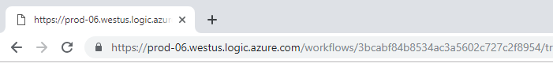

Note that after browsing to this URL, the browser should display an empty page because the flow with the HTTP trigger doesn't pass any data back in the HTTP response. However, the flow should have run and completed the work to create a new SharePoint list item.

* 1. Refresh the browser a few more times. Each time you refresh the browser, it should trigger the flow to run again.

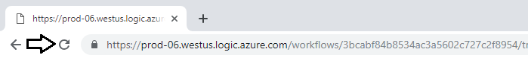

* 1. Return to the RUN HISTORY page and refresh it. You should see a run for each HTTP request you submitted.

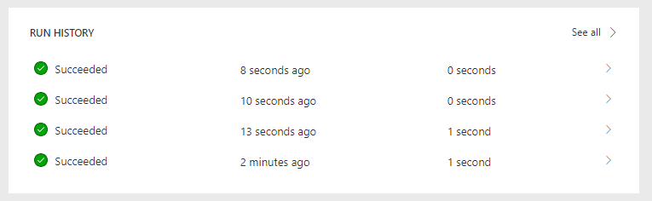

1. Create a new parent flow named **Add Multiple Customers** which calls the **Add New Customer with HTTP trigger** flow.
   1. Create a new flow from blank as you did earlier in this lab.

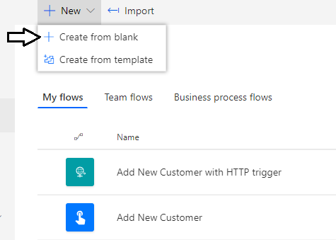

* 1. Once the flow has been created, update its name to **Add Multiple Customers**.



* 1. Select the trigger named **Manually trigger a flow**.

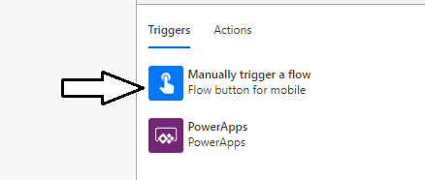

* 1. Click **+ Add an input** to add a new parameter to the trigger.

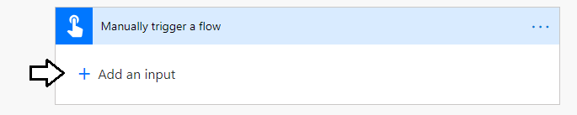

* 1. When prompted to **Choose the type of user input**, select **Number**.

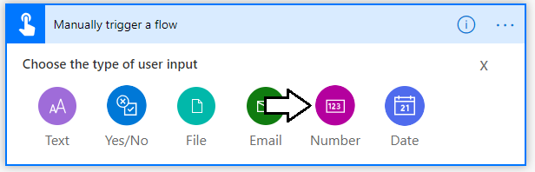

* 1. Give the input parameter a name of **Customer Count** and a caption of **Please enter the number of customers requested**.

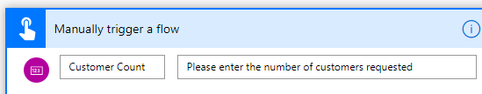

1. Add a new action to initialize a new variable named **Loop Counter**.
   1. Click **New step** to add a new action underneath the trigger named **Manually trigger a flow**.

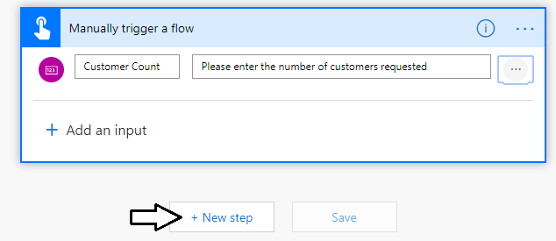

* 1. Type **initialize variable** in the search box. Find and select the action named **Initialize variable**.

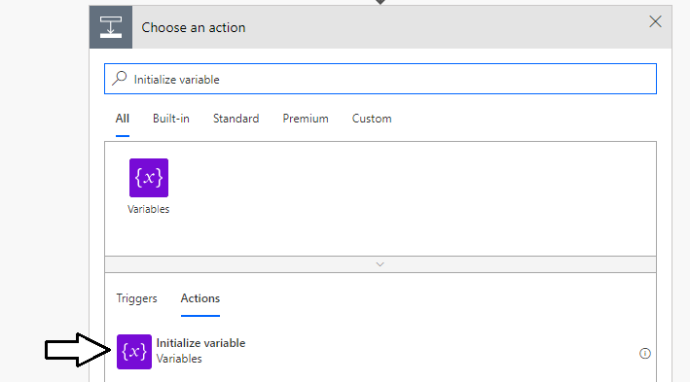

* 1. Set the **Name** parameter to **Loop Counter**.
  2. Set the **Type** parameter to **Integer**.
  3. Set the **Value** parameter to **1**.

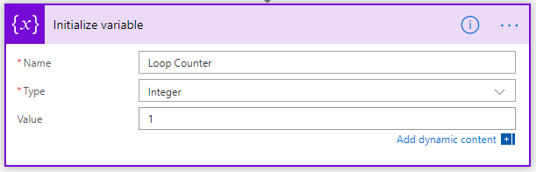

1. Add an action for a **Do Until** loop
   1. Click **New step** to add a new action to the bottom of the flow.
   2. Type **Do until** in the search box. Find and select the action named **Do until**.

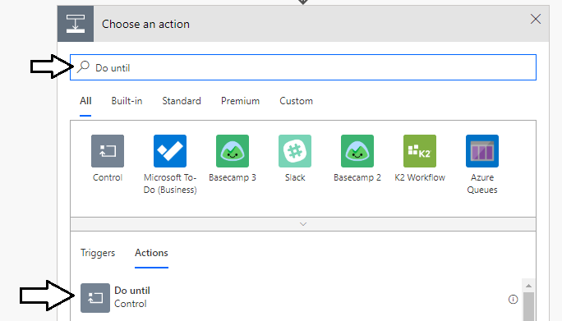

* 1. Set the Do until loop conditionto **Loop Counter** **is greater than Customer Count** as shown in the following screenshot.

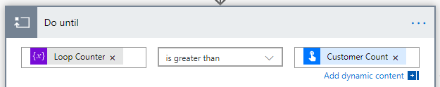

* 1. Click the **Add an action** link inside the **Do until** action.

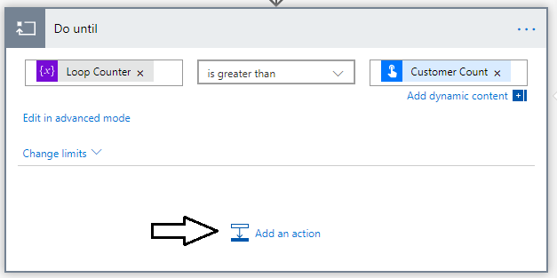

* 1. Type **HTTP** in the search box. Locate and select the **HTTP** action.

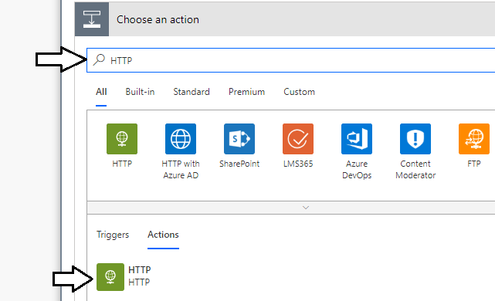

* 1. Set the Method parameter to **GET**.

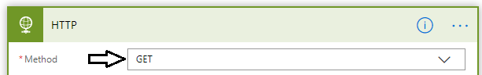

* 1. Update the **URI** parameter and copying and pasting the **HTTP GET URL** value that you copied to notepad earlier.

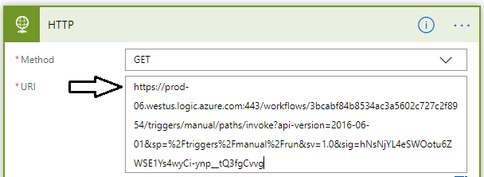

1. Add a **Increment Variable** action to increment the Loop Counter variable on each iteration through the **Do Until** loop
   1. Click **New step** to underneath the **HTTP** action to add a new action to the bottom of **Do until** action.
   2. Type **Increment Variable** in the search box. Find and select the action named **Increment Variable**.

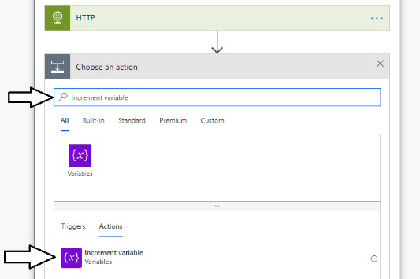

* 1. Set the **Name** to **Loop Counter**.
  2. Set the **Value** to **1**.

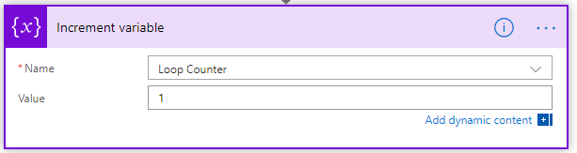

* 1. Click **Save** in the upper right corner to save your work.



Now have now completed the work on both the parent flow and the child flow. When you run the **Add Multiple Customers** flow, you should be able to set the desired number of customers using the **Customer Count** user input parameter. When this parent flow executes, it should call the Add Customer using HTTP trigger once for each customer.

1. Test your work by running the **Add Multiple Customers** flow.
   1. Click Test in the upper right corner.



* 1. Select the **I'll perform the trigger action** option and then click the **Test** button.
  2. The **Run flow** dialog should appear with a user input control to set a value the **Customer Count** parameter.

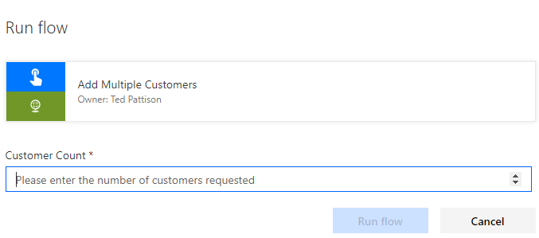

* 1. Click the upward arrow button on the right side of the **Customer Count** input control three times to set its value to **3**.



* 1. With the **Customer Count** parameter set to **3**, click **Run flow** to begin the test run.

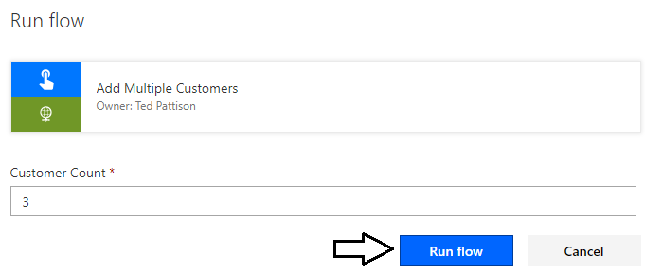

* 1. When you see the dialog indicating the flow has started successfully, click **Done** to continue.

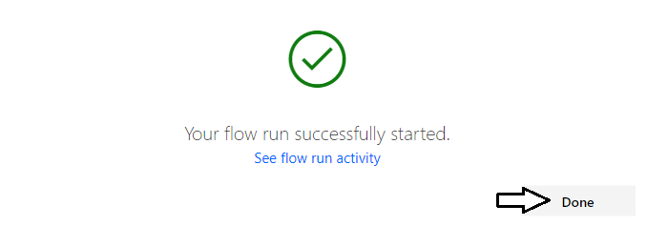

* 1. Examine the flow history inside the **Do until** action which shows the loop ran three times.
  2. Click the **Next** button to see the history of each iteration inside the **Do until** loop.

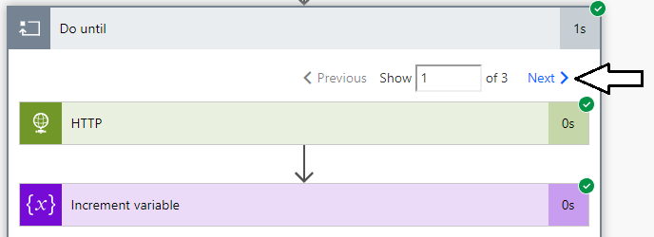

* 1. Navigate to the Customer list in your SharePoint Online site and verify that new three customers have been added.

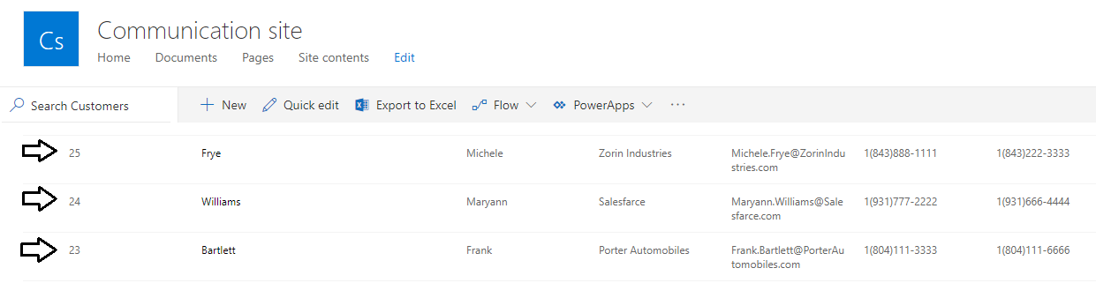

Try running the **Add Multiple Customers** flow and setting the **Customer Count** to **100**. How long does it take flow to add 100 new list items into the Customers list in SharePoint Online.

### Exercise 3: Create a Custom Connector for an External Web Service

In this exercise, you will create a custom connector to retrieve customer data from the same web service you worked with in the first exercise of this lab. One key benefit of creating a custom connector is that you can use it when building a canvas app.

1. Create a new custom connector.
   1. Navigate to the PowerApps portal at <https://web.PowerApps.com> and sign in with your Office 365 account.
   2. Make sure you are working in the same environment where you have completed your other lab exercises.
   3. Expand the **Data** section in the left navigation and then click the **Customer connectors** link.

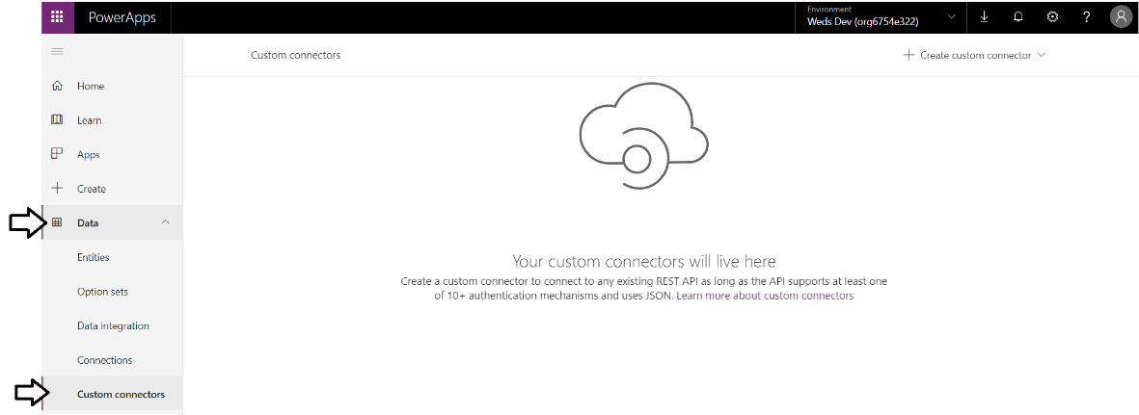

* 1. Drop down the **Create custom connector** menu in the top right and select the **Create from blank** command.

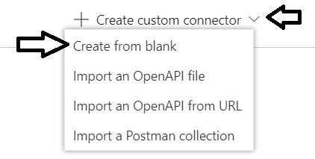

* 1. Enter a **Customer connector name** of **CustomersAPI** and then click **Continue**.

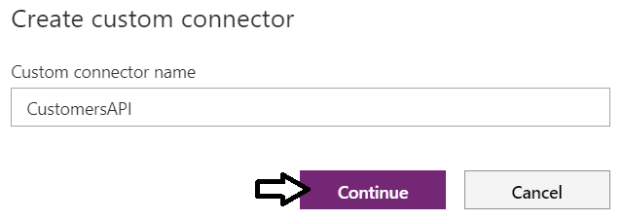

1. Fill out the General information page for the custom connector.
   1. In the **General information** section, click the **Upload** button to upload a connector icon.

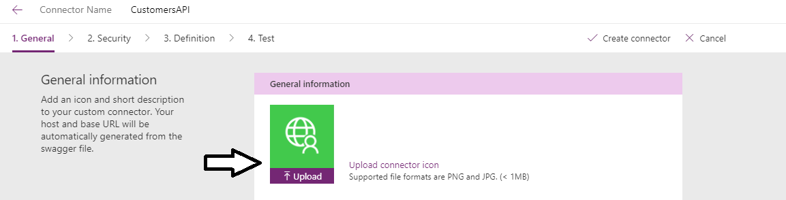

* 1. Upload an icon file for your custom connector using the PG file at the following path.

C:\Student\Extras\Images\AppIcon.png

* 1. Verify that the icon file has been successfully uploaded.

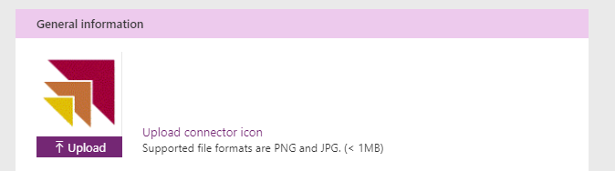

* 1. Add a **Description** of **A custom connector to retrieve customer data**.

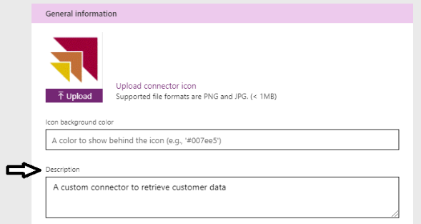

* 1. For the **Scheme** setting, select **HTTP**.
  2. For the **Host**, enter a value of **subliminalsystems.com**.
  3. For the **Base URL**, enter a value of **/api/**.

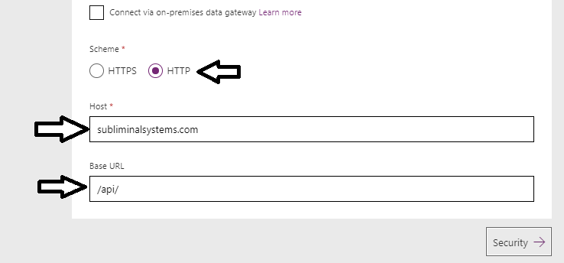

* 1. Click the **Security** link at the bottom of the **General information** page to move ahead to the **Security** page.



The web service at <http://subliminalsystems.com> is accessible through anonymous access so you do not need to configure security.

* 1. Click the **Definition** link at the bottom of the **Security** page to move ahead to the **Definition** page.

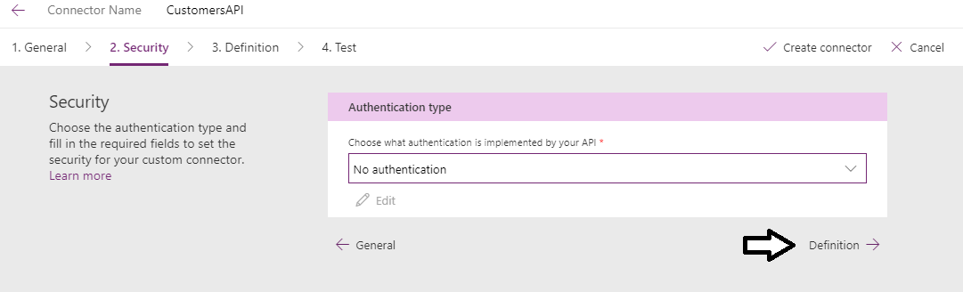

1. Create the **GetCustomers** action.
   1. Click the **New action** link in the **Definition** page.

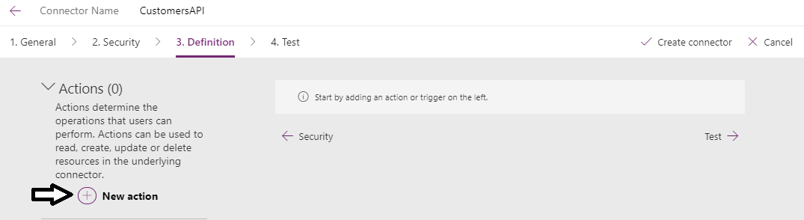

* 1. In the **General** section, enter a **Summary** of **Get Customers**.
  2. Enter a **Description** of **An operation to retrieve customer data**.
  3. Enter an **Operation ID** of **GetCustomers**.

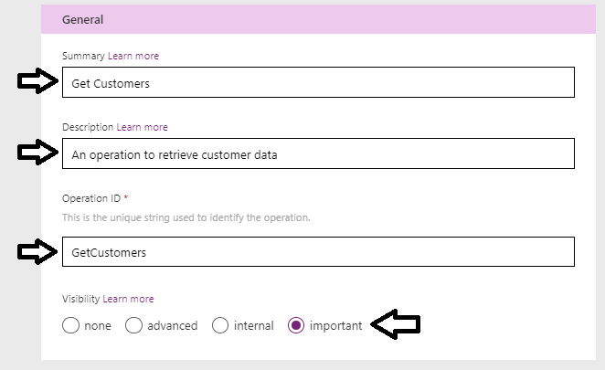

* 1. Move down to the **Request** section and click the **Import from sample** link.

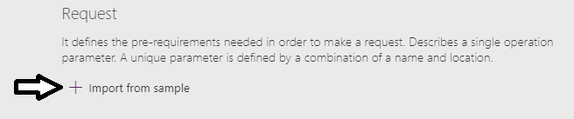

The **Import from sample** pane should open on the right side of the screen.

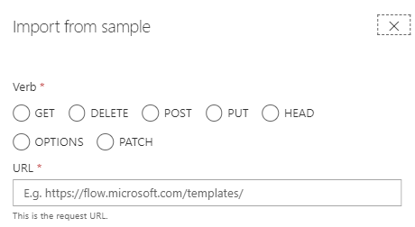

* 1. For the **Verb** setting, select **GET**.
  2. Copy the following URL and paste it into the textbox for the **URL**.

http://subliminalsystems.com/api/Customers/?$select=LastName,FirstName,CustomerId&$filter=startswith(LastName, 'A')

* 1. Click **Import** to import the data from sample URL.

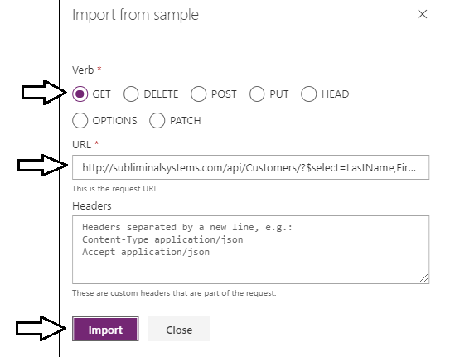

1. Configure the **Query** parameters named **$select** and **$filter**.
   1. Once the URL has been imported, you should see the **URL** has been set to **http://subliminalsystems.com/api/Customers**.

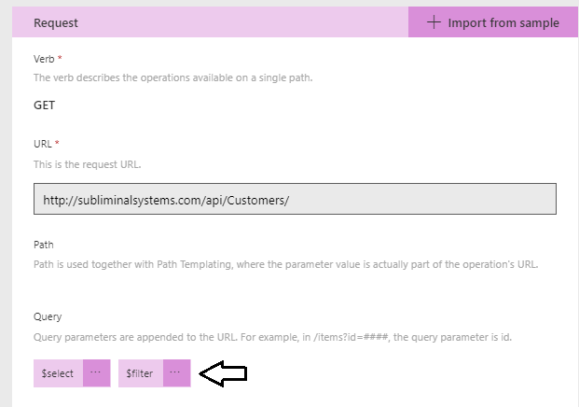

* 1. Below the URL, you should also see two **Query** parameters that have been created name **$select** and **$filter**.



* 1. Drop down the context menu for the **$select** query parameter and click the **Edit** command to display the **Parameter** dialog.

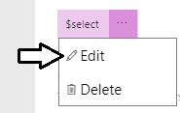

* 1. In the **Parameter** dialog for the **$select** parameter, enter a **Default value** using the following text.

LastName,FirstName,CustomerId

* 1. Set the **Is required** setting to **Yes**.
  2. Set the **Visibility** setting to **internal**.

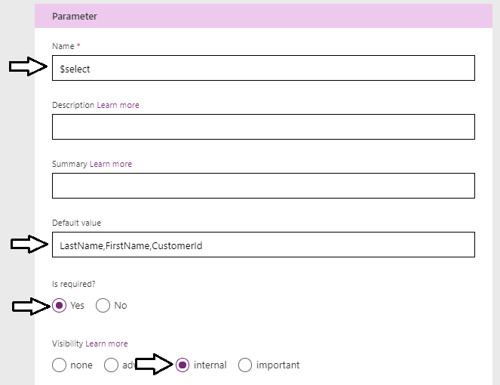

* 1. Click the **Back** arrow to move from the **Parameter** dialog back to the action definition.

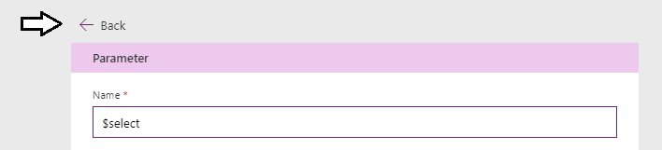

* 1. You should now be back on the page which displays the two **Query** parameters named **$select** and **$filter**.



* 1. Drop down the context menu for the **$filter** query parameter and click the **Edit** command to display the **Parameter** dialog.

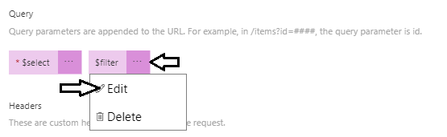

* 1. In the **Parameter** dialog for the **$filter** parameter, enter a **Default value** using the following text to return all customer records.

length(LastName) gt 0

* 1. Set the **Visibility** setting to **important**.

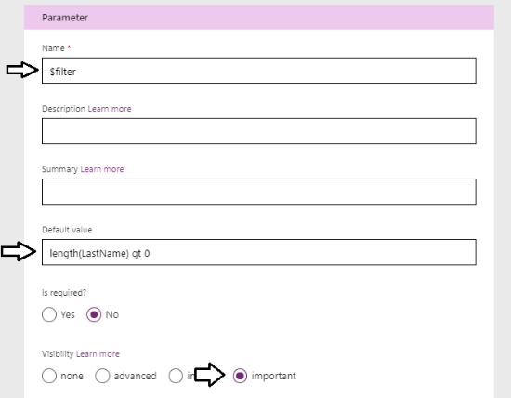

* 1. Click the **Back** arrow to move from the **Parameter** dialog back to the action definition.

1. Define the Response for the **GetCustomers** action.
   1. Move down in the page for the **GetCustomers** action to the **Response** section and click the **Add default response** link.

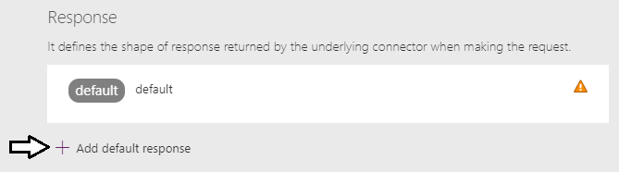

* 1. Copy and paste the following JSON result into the **Body** textbox on the **Import from sample** pane.

{

"value":[

{

"CustomerId":1,

"FirstName":"Madeline",

"LastName":"Jenkins"

}

]

}

* 1. Once you have added the JSON into the **Body** textbox, click **Import**.

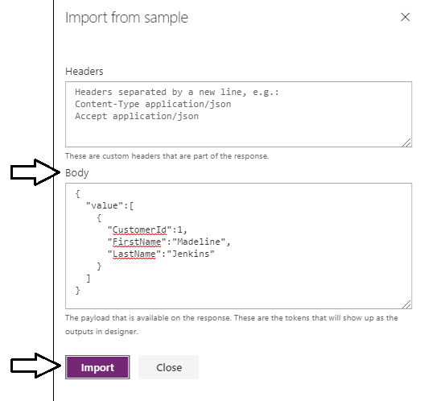

* 1. Check your work by clicking the **default** section in the **Response** section as shown in the following screenshot.

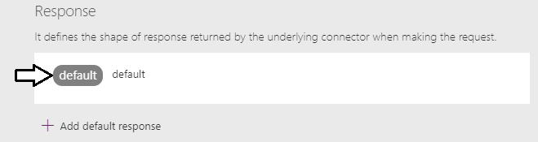

* 1. You should be able to verify that the **Body** contains properties for **CustomerId**, **FirstName** and **LastName**.

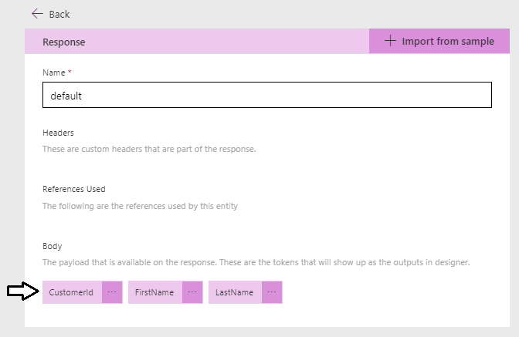

* 1. Click the **Back** arrow to move from the **Response** dialog back to the action definition.

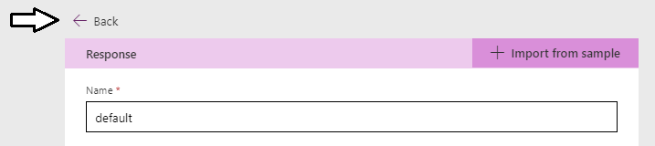

1. Save your changes and test the custom connector.
   1. Click the **Create connector** link at the top right to save the **CustomerAPI** custom connector.

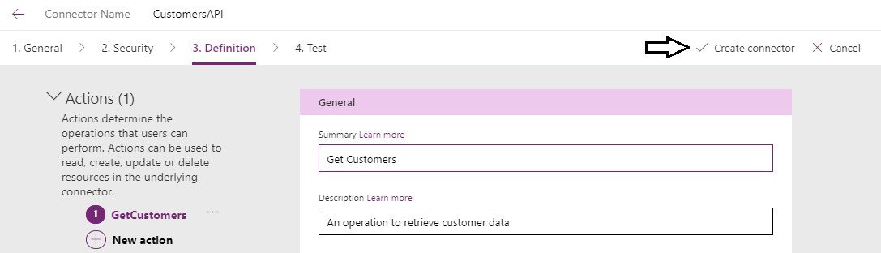

* 1. Once the **CustomerAPI** custom connector has been created, click the **Test** link to navigate to the **Test** page.

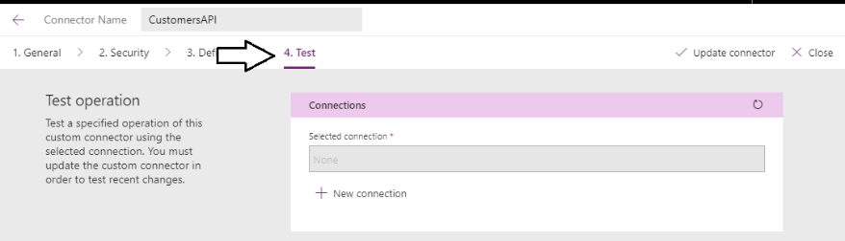

* 1. Click the **New connection** link to create a new connection for your custom connector.

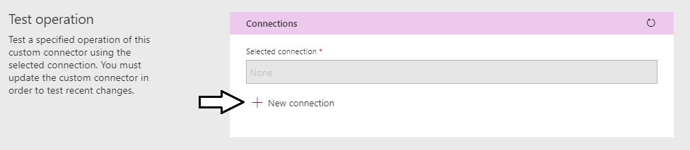

* 1. When you are prompted with the **CustomersAPI** dialog, click the **Create** button to create a new connection.

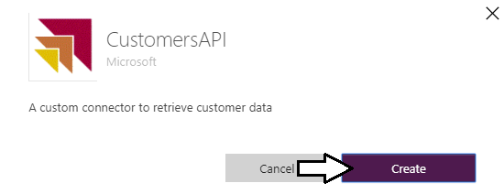

* 1. You should now be redirected to the **Connection** page where you can see that the new connection has been created,

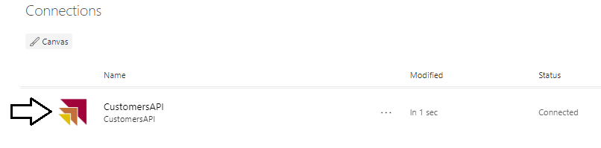

* 1. Navigate back to the **Custom connectors** page.

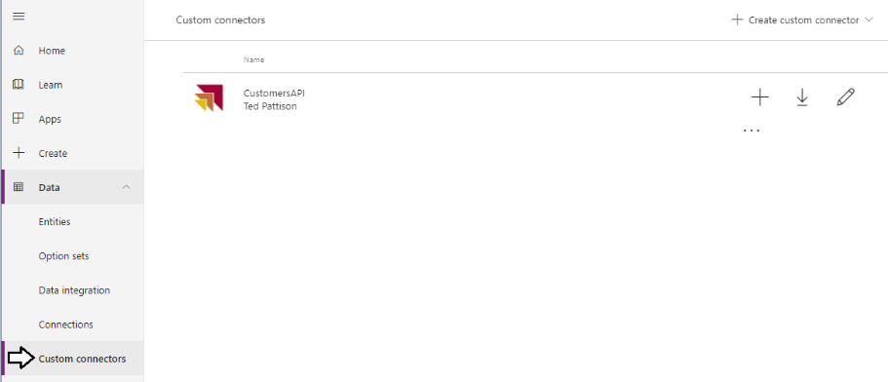

* 1. Click on the edit link with the pen icon to return to edit mode for the **CustomersAPI** custom connector.

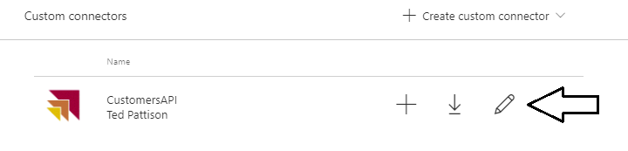

* 1. Return to the **Test** page for the custom connector.

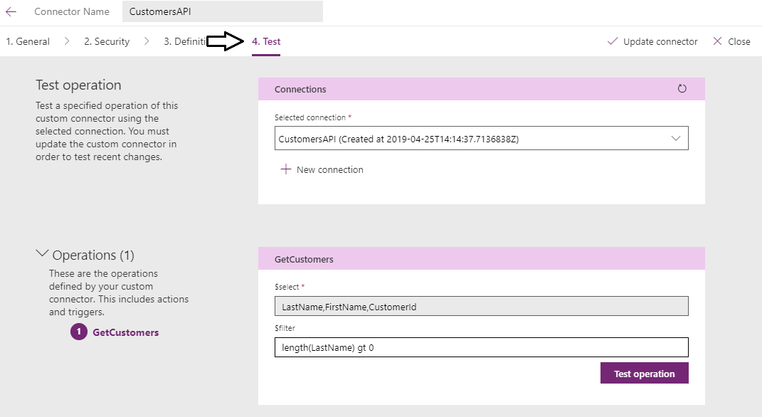

* 1. Without changing the default value of the **$filter** parameter, click the **Test operation** button.

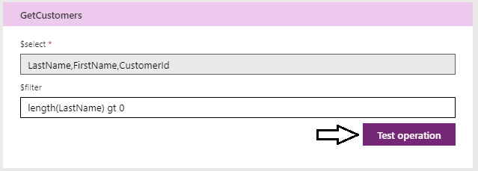

* 1. You should see the **Response** contains with custom data.

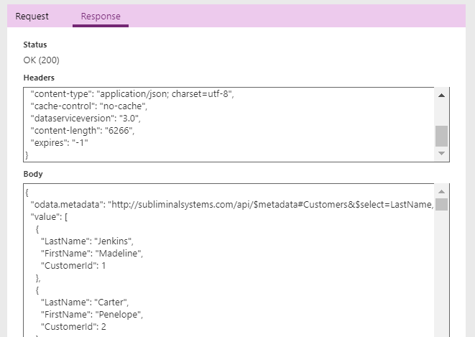

* 1. Replace the default value for the **$filter** parameter with the following text.

startswith(LastName, 'A')

* 1. Click the **Test operation** button again to retrieve custom data using the new filter value..

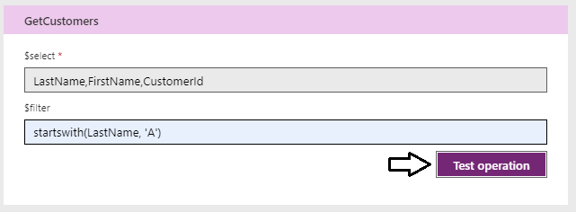

* 1. You should be able to verify that only customers whose last names start with "A" are returned in the response.

You have now successfully created the first action for the **CustomersAPI** custom connector named **GetCustomer**. Now you will create a second action named **GetCustomer** that will accept a **CustomerId** and return a single customer instance.

1. Create a second operation named **GetCustomer**.
   1. Navigate to the **Definition** page.

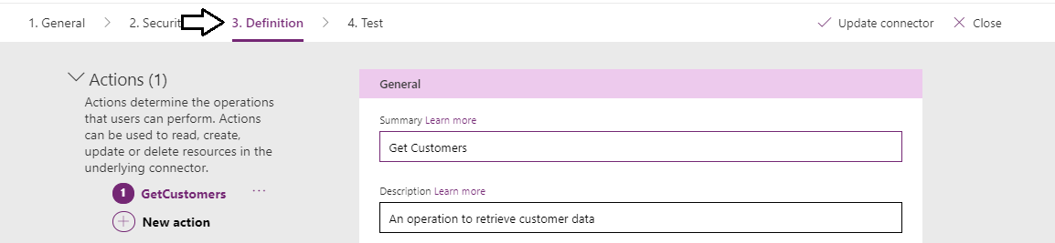

* 1. Click the New action link to create a new action.

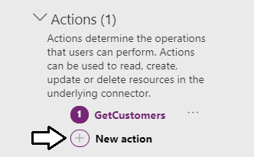

* 1. For the **Summary** setting, enter **Get Customer**.
  2. For the **Description** setting, enter **an operation to retrieve a single customer**.
  3. For the **Operation ID** setting, enter **GetCustomer**.
  4. For the **Visibility** setting, select **important**.

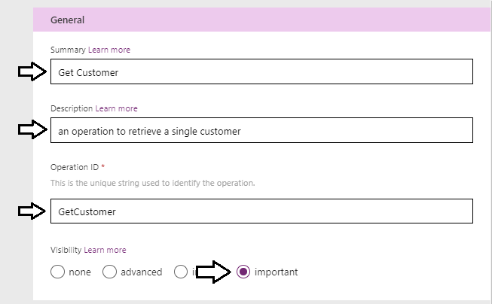

* 1. Move down to the **Request** section and click the **Import from sample** link.

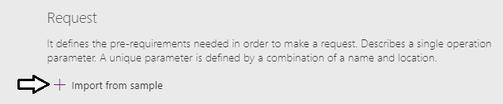

* 1. The **Import from sample** pane should open on the right side of the screen.
  2. For the **Verb** setting, select **GET**.
  3. Copy the following URL and paste it into the textbox for the **URL**.

http://subliminalsystems.com/api/Customers({CustomerId})

* 1. Click the **Import** button.

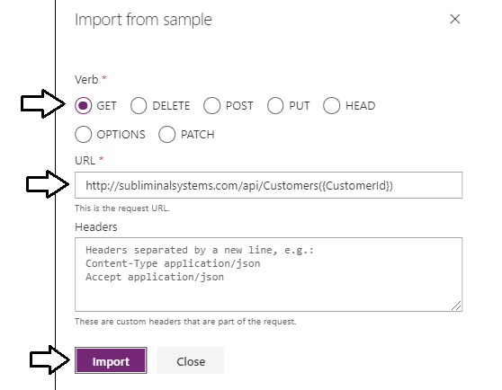

* 1. After running the **Import** operation, you should see a new **Path** parameter named **CustomerId**.

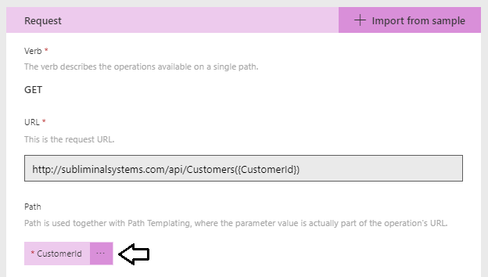

* 1. Drop down the context menu for the **CustomerId** Path parameter and click the **Edit** command.

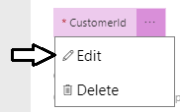

* 1. On the **Parameter** dialog for the **CustomerId** parameter, set the **Is required** setting to **Yes**.

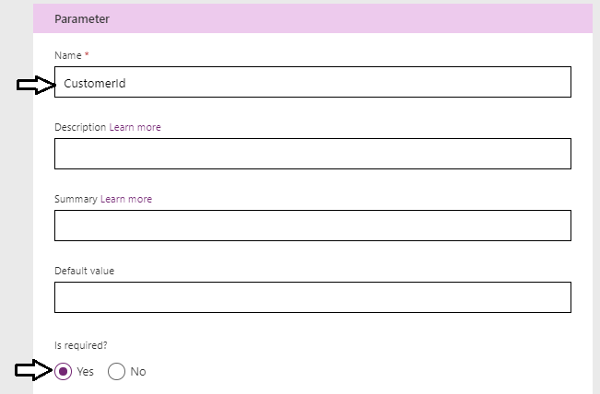

* 1. Underneath the **Is required** property, set the **Visibility** property to **important**.
  2. Set the **Type** to **integer**.

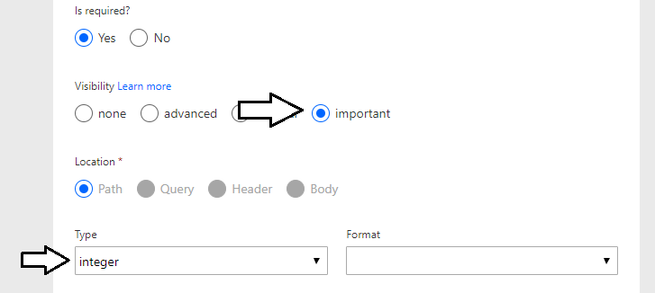

* 1. Click the **Back** arrow to move from the **Response** dialog back to the action definition.

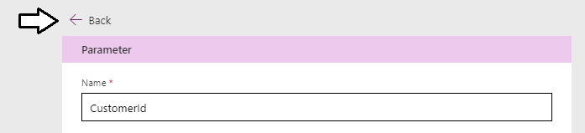

1. Define the Response for the **GetCustomer** action.
   1. Move down in the page for the **GetCustomer** action to the **Response** section and click the **Add default response** link.

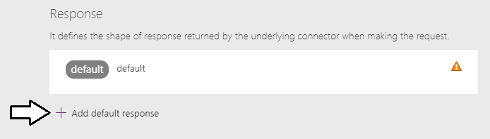

You should now see the **Import from sample** pane on the right side of the screen.

* 1. Locate the textbox for the **Body**.

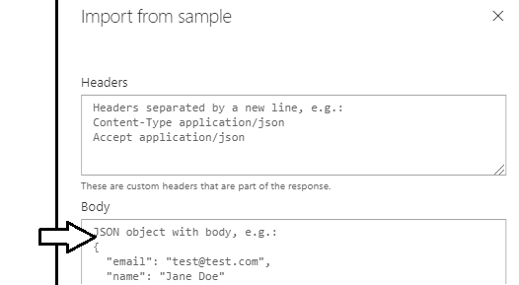

* 1. Copy and paste the following JSON content with customer data into the clipboard.

{

"CustomerId": 47,

"FirstName": "Cordell",

"LastName": "Bridges",

"Company": "Massive Dynamic",

"EmailAddress": "Cordell.Bridges@MassiveDynamic.com",

"WorkPhone": "1(803)444-5555",

"HomePhone": "1(803)111-8888",

"Address": "2020 Power Platform Avenue",

"City": "Tampa",

"State": "FL",

"Zipcode": "11111"

}

* 1. Paste the contents of the clipboard into the **Body** textbox in the **Import from sample** pane.

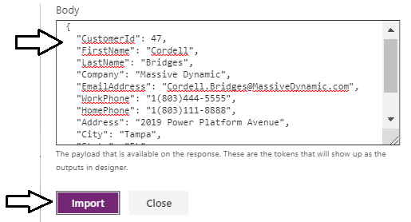

* 1. Click the **default** response to view the its details and to verify the customer properties have been created.

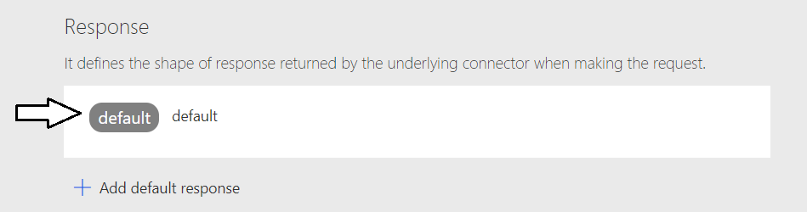

* 1. In the **Body** of the default response, you should see the see of customer properties such as **FirstName**, **LastName**, etc.

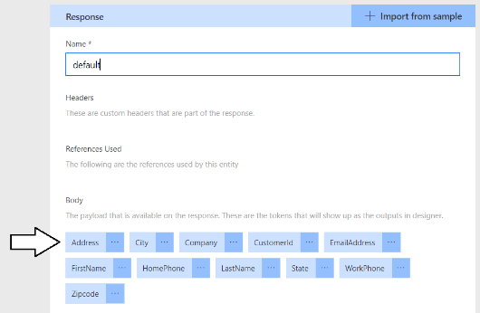

* 1. Save your changes to the custom connector by clicking the Update connector button in the top right of the page.

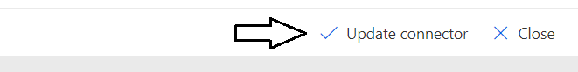

1. Test your work.
   1. Navigate to the **Test** page.
   2. Enter a **CustomerId** value of **3** and then clock the **Test operation** button.

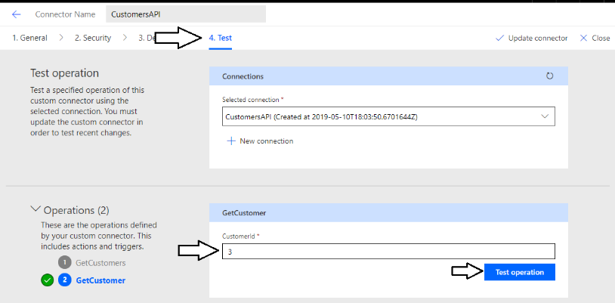

* 1. When you click the **Test operation** button, you should see the JSON for a single customer object in the **Response** tab below.

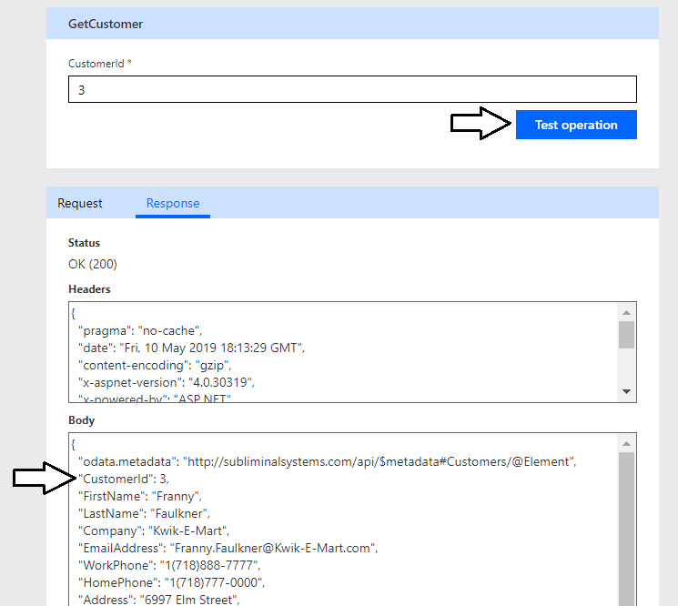

You have now completed building the CustomersAPI custom connector.

### Exercise 4: Creating a Custom Connector for the Power BI Service API

In this exercise, you will create a custom connector to call the Power BI Service API. You will start by registering an application with Azure AD. Then you will create a custom connector in PowerApps that uses the Azure AD application to call the Power BI Service API.

1. Log into the Azure Portal
   1. In the browser, navigate to the Azure portal at <https://portal.azure.com>.
   2. When you are prompted to log in, provide the credentials to log in with your Office 365 user account name.
   3. Once you have logged into the Azure portal, check the email address in the login menu in the upper right to make sure you are logged in with the correct identity for your new Office 365 user account.

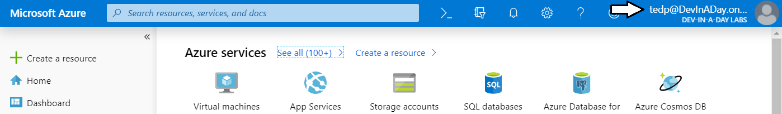

1. Register a new Azure AD application.
   1. In the left navigation, scroll down and click on the link for **Azure Active Directory**.
   2. Click the link for **App registration**.

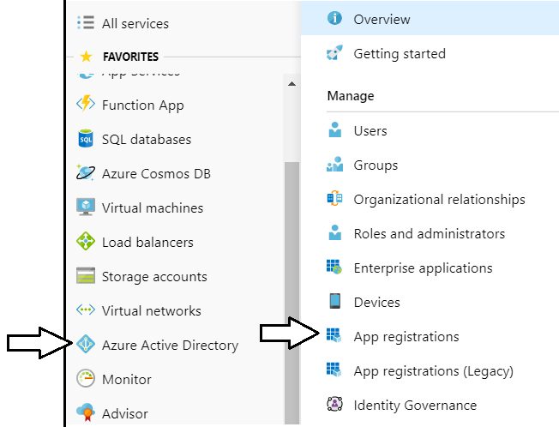

Note that the Azure portal user experience for creating and configuring Azure AD applications was updated in April 2020. If you start feeling nostalgic, you can get back to the old user experience by clicking the **App registrations (Legacy)** link.

* 1. Click **New registration**.

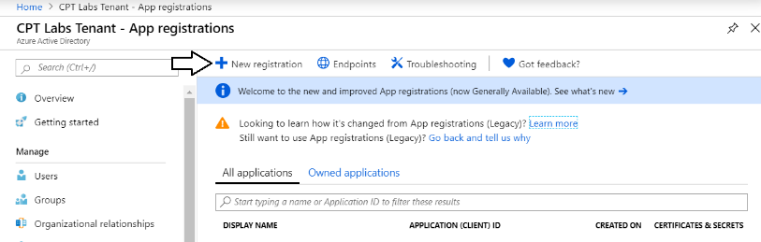

* 1. Enter a **Name** of **Custom Connector for Power BI**.

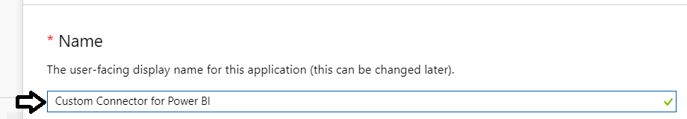

* 1. For the **Supported account types** option, leave the default value of **Accounts in this organizational directory only**.

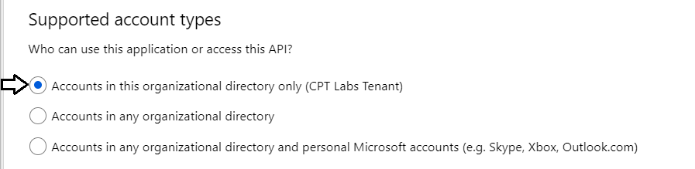

* 1. In the **Redirect URI** section, select **Web** in the left dropdown.
  2. In the textbox to the right, leave it empty as you will need to return and add this later in this lab exercise.
  3. Click the **Register** button to create the new Azure AD application.

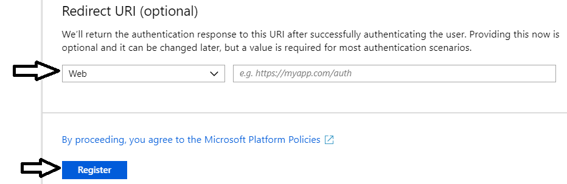

* 1. Once you've created the new application you should see the application summary view as shown in the following screenshot..

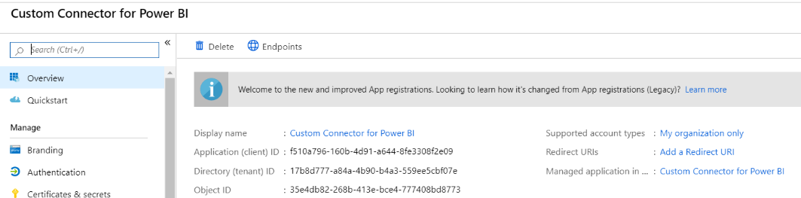

* 1. Copy the **Application ID** to the Windows clipboard.

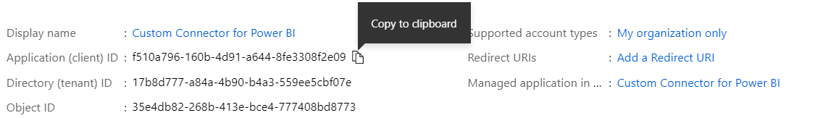

* 1. Launch Notepad and paste the **Application ID** into a new text file. Save the text file as **CustomConnectorInfo.txt**.

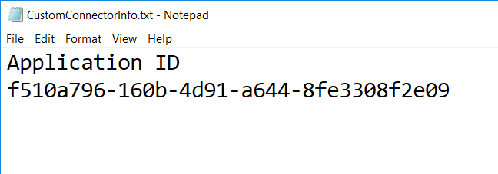

1. Configure required permissions for the Azure AD application.
   1. Click the **API permissions** link on the left.
   2. Click the **Add a permission** button in the **API permissions** section.

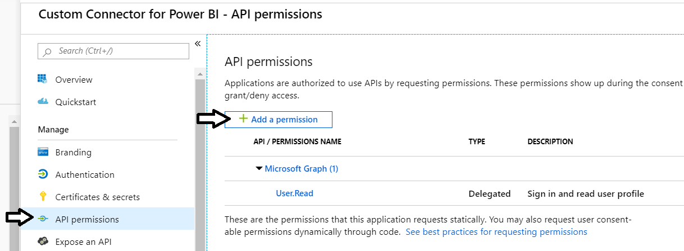

* 1. On the **Microsoft APIs** tab, click **Power BI Service**.

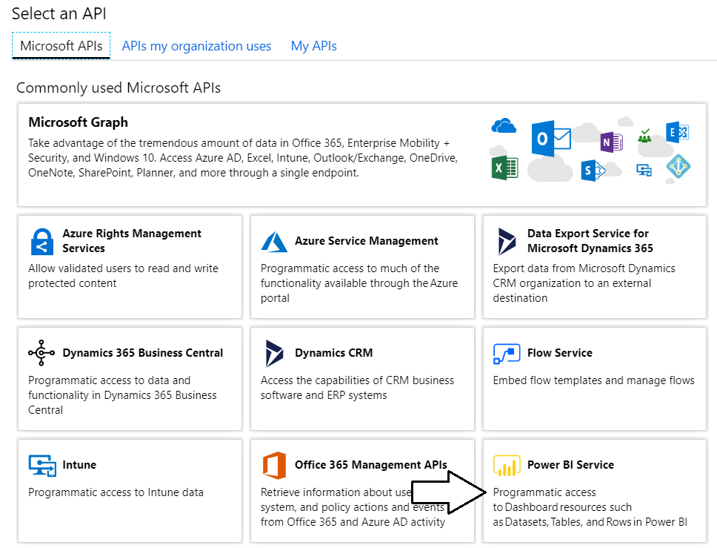

* 1. Click **Delegated Permissions**.

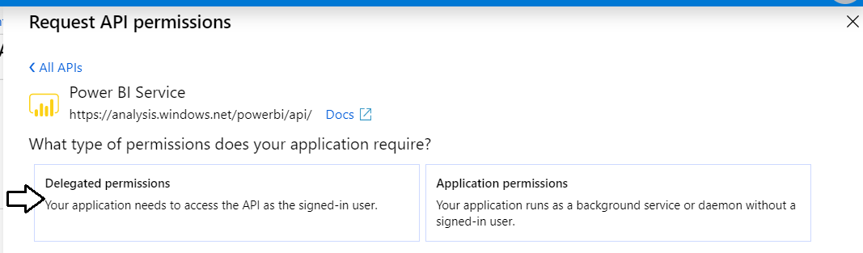

* 1. In the **PERMISSION** section, expand **Dataset** and select the **Dataset.ReadWrite.All** permission.

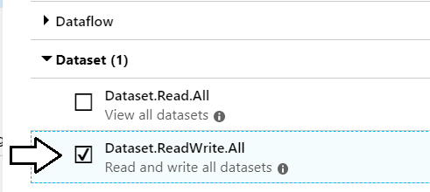

* 1. Expand **Group** and select the **Group.Read.All** permission.

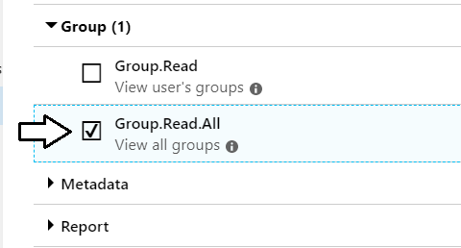

* 1. At this point, you should see that the Power BI Service permissions have been added to the **Required permissions** list.

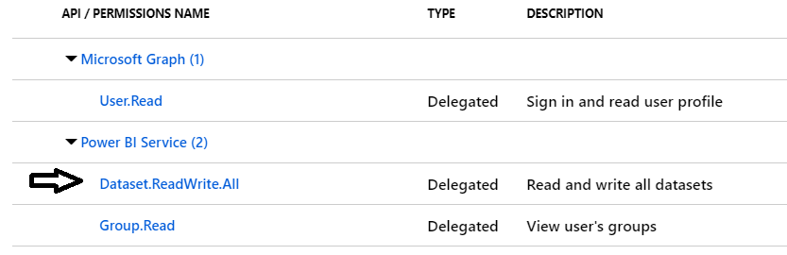

1. Create the application secret for the Azure AD application.
   1. Click **Certificates and secrets** in the left navigation and then click **New client secret**.

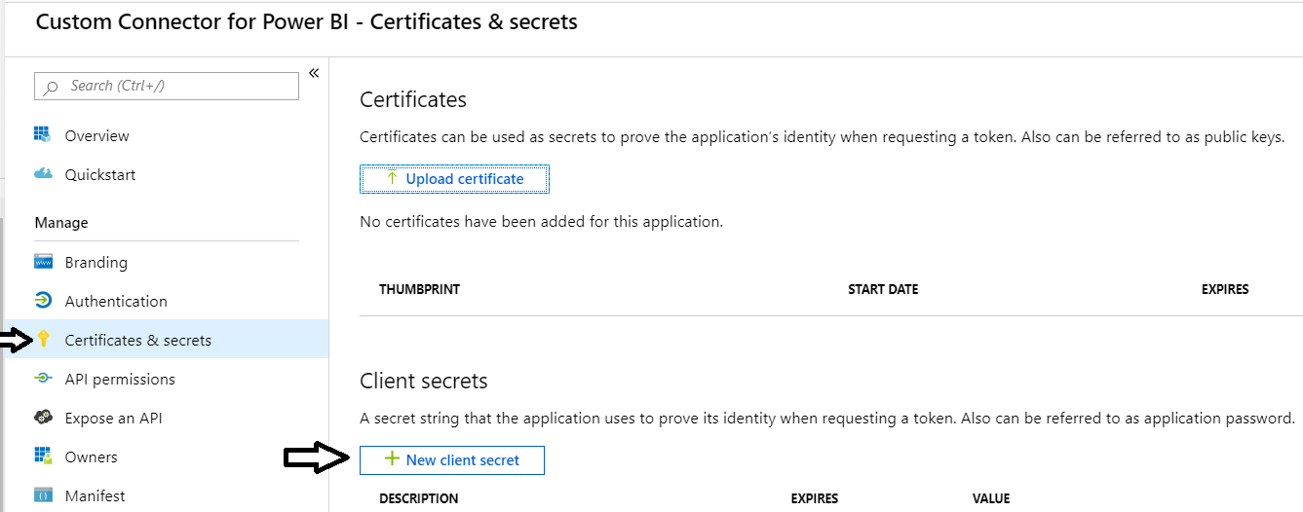

* 1. Add a **Description** of **Key1** and then click **Add**.

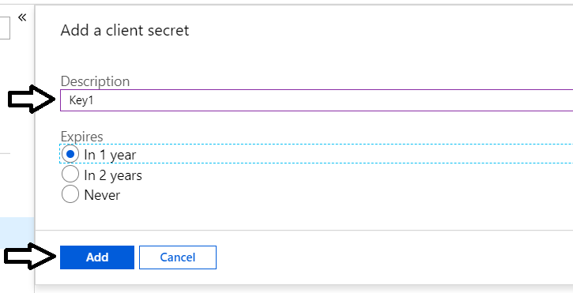

* 1. Once the new secret has been created, copy its value to the Windows clipboard.

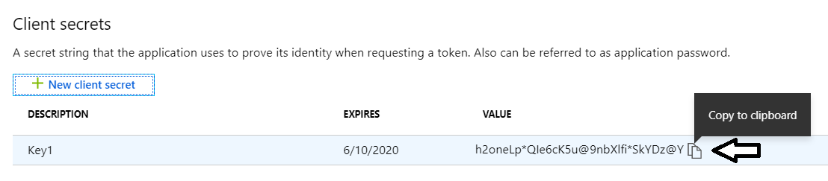

* 1. Copy the secret into the same text file that contains the Application ID.

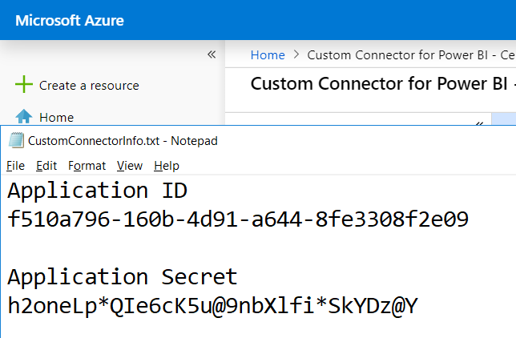

1. Create the custom connector in PowerApps.
   1. Locate the file in the ZIP archive download named **Power-BI-Datasets-API.swagger.json**.
   2. Navigate to the PowerApps Maker portal at <https://make.powerapps.com/home>.
   3. Navigate to the **Data > Custom Connectors** link.

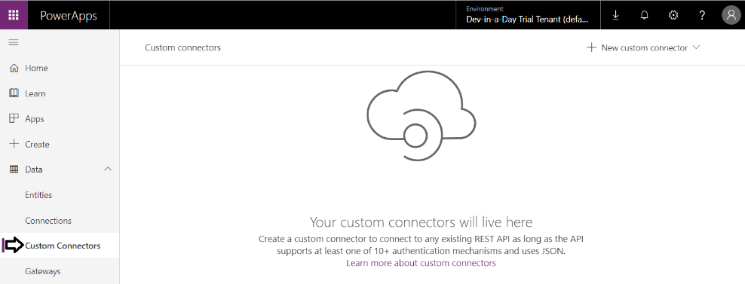

* 1. Click **New custom connector**.

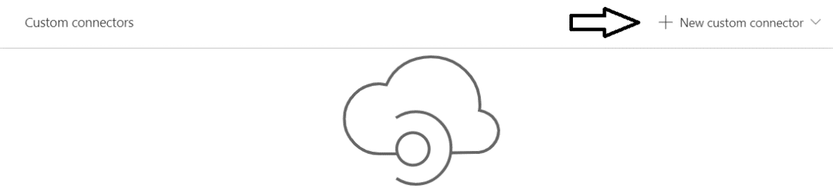

* 1. From the dropdown menu, click **Import an OpenAPI file**.

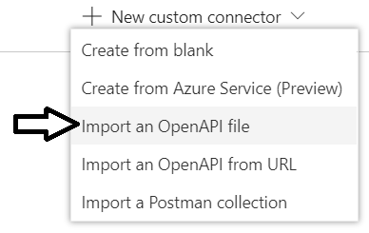

* 1. Type in a **Connector name** of **PowerBiDatasetsAPI** and then click **Import**.

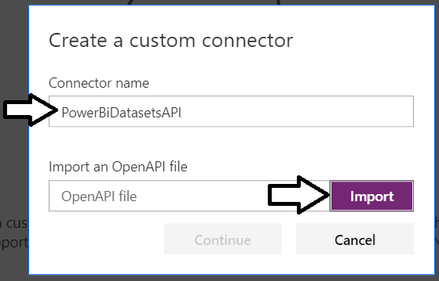

* 1. Select the file from the ZIP archive download named **Power-BI-Datasets-API.swagger.json** and click **Open**.

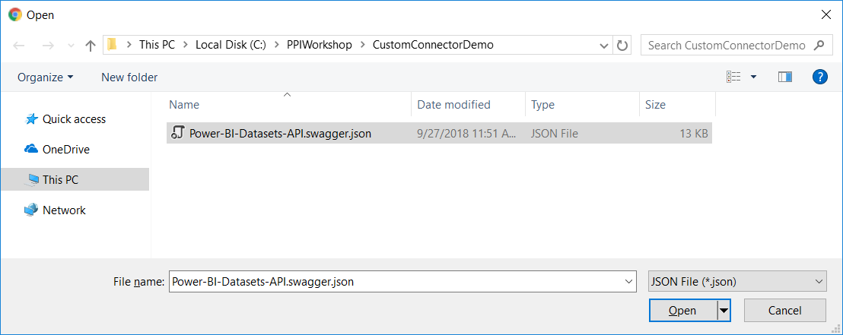

* 1. Click the **Continue** button to create the new custom connector.

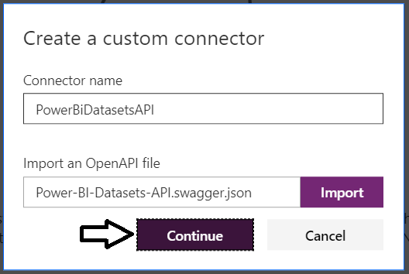

* 1. You should now see the **General** tab for the new custom connector.

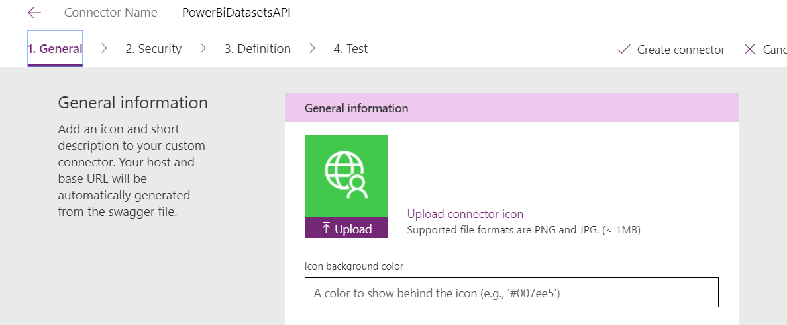

* 1. Click the Upload button to upload a custom icon.

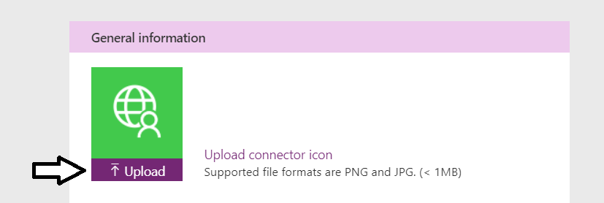

* 1. Select the file from the ZIP archive download named **AppIcon.png** and click **Open**.

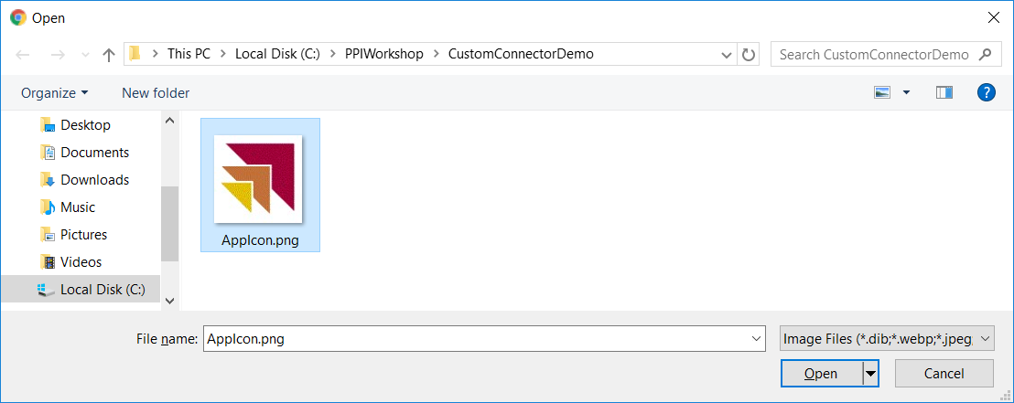

* 1. You should now see the custom icon.

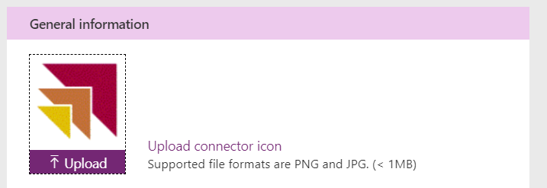

1. Configure security settings for the new custom connector.
   1. Click the **Security** to navigate to the Security tab

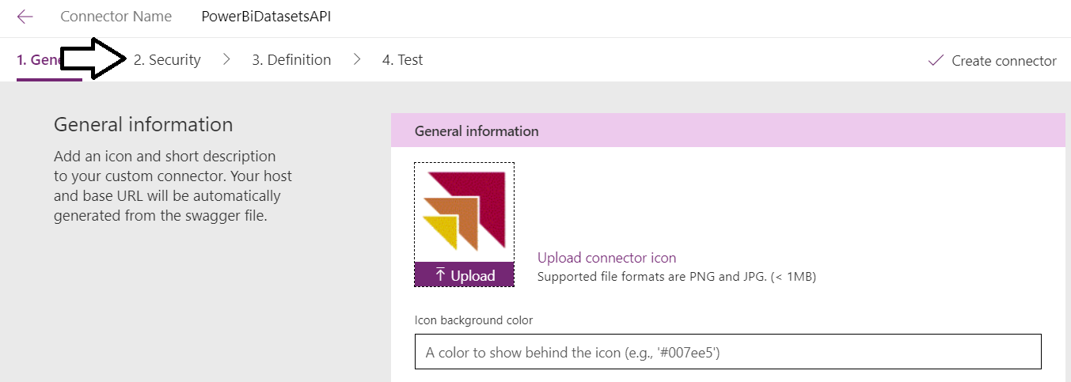

* 1. On the **Security** tab, notice that he **Client Id** value and the **Client secret** value need to be filled in.

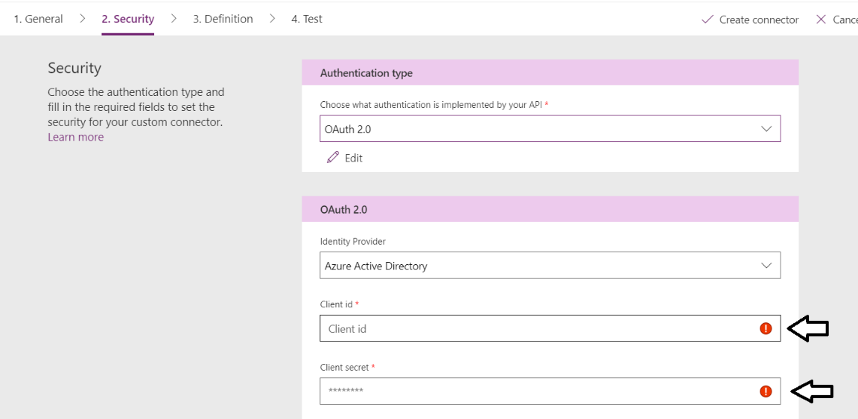

* 1. Fill in the **Client Id** and the **Client secret** values with the **Application ID** and the **Application Secret** values from Notepad.

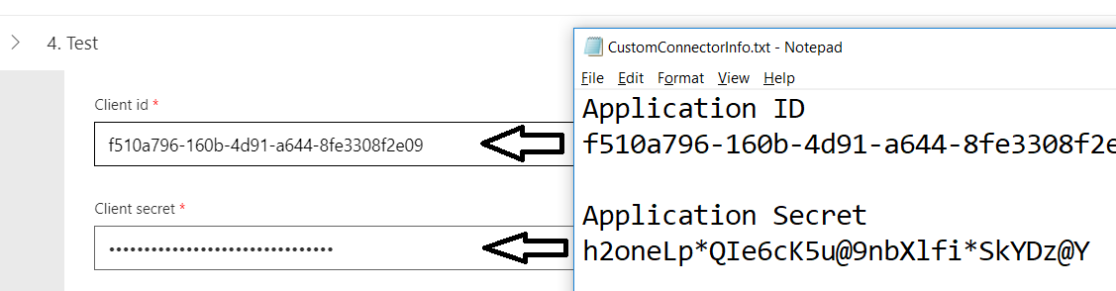

* 1. Enter a value for the **Resource URL** of **https://analysis.windows.net/powerbi/api**.

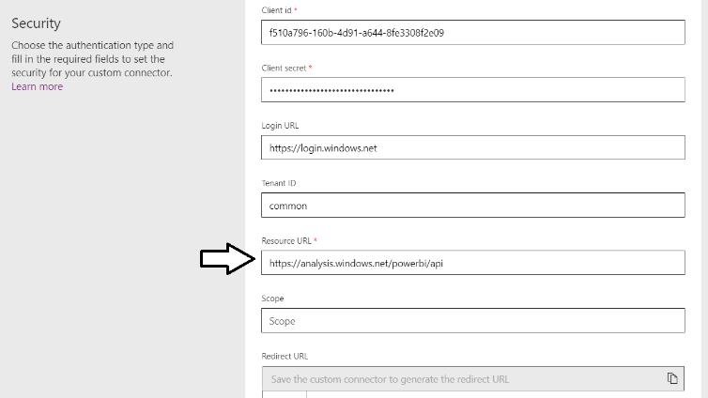

You can leave all the other textboxes in their default vaues.

* 1. Click **Create connector**.

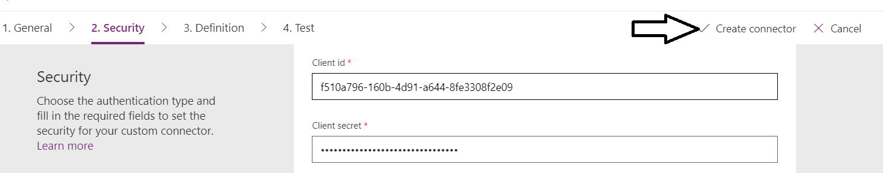

* 1. Once the connector has been created, copy the Redirect URL from the bottom of the **Security** tab.

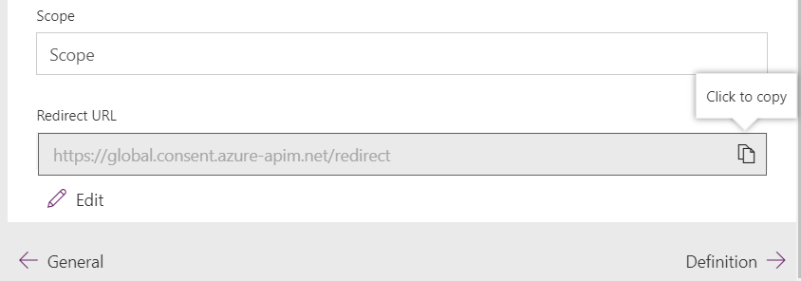

As a final step, you must take the Redirect URL value and REDIRECT URI vale fo the Azure AD application.

* 1. Return to the Azure portal and **Authentication** view for the Azure AD application named **Custom Connector for Power BI**.
  2. Locate the **REDIRECT URI** textbox and add your cursor inside.

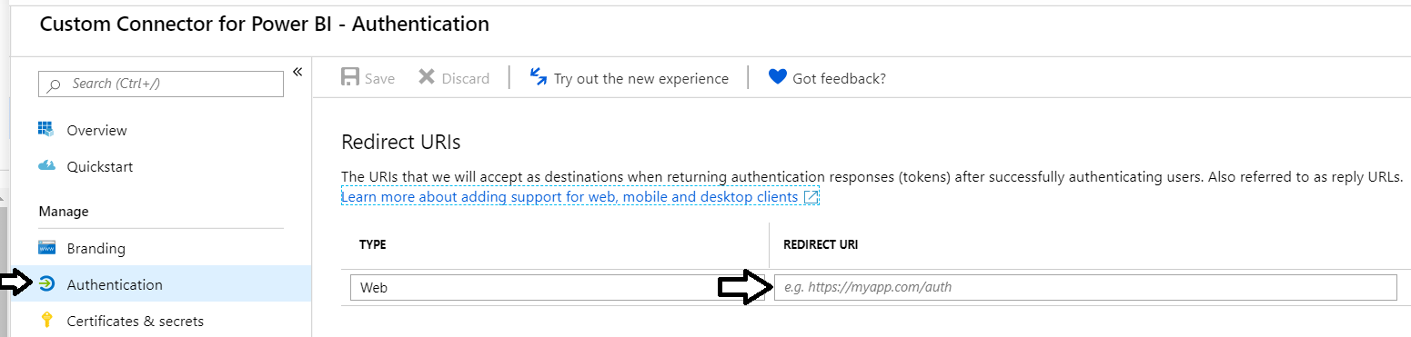

* 1. Paste in the Redirect URL you coped from the PowerApps custom connector and then click **Save**.

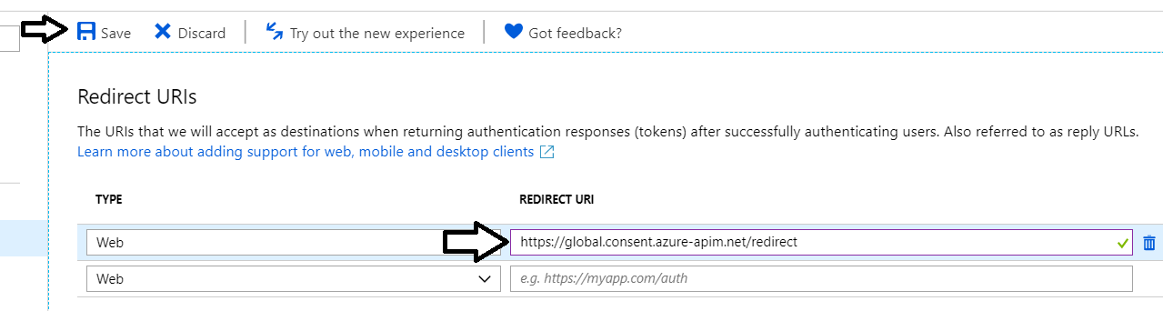

1. Create a new connection for the new custom connector.
   1. Move back to the browser tab with the custom connector and navigate to the **Test** tab.
   2. Click the **New connection** link.

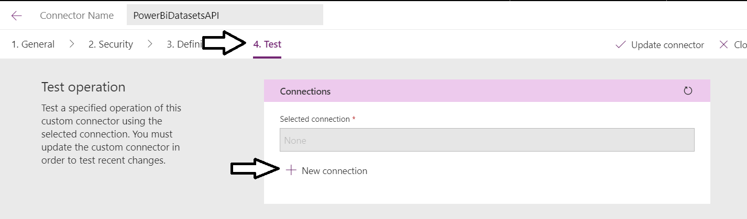

* 1. Click **Create** to create the new connection.

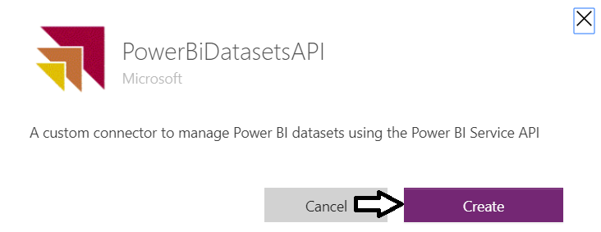

* 1. When prompted, log in with the same account you have been using.

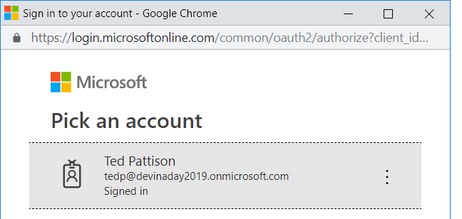

* 1. When prompted to consent to **Permissions requested**, click **Accept**.

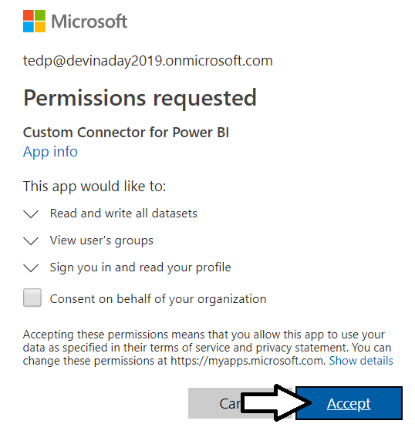

* 1. You should see that the new connection has been created.

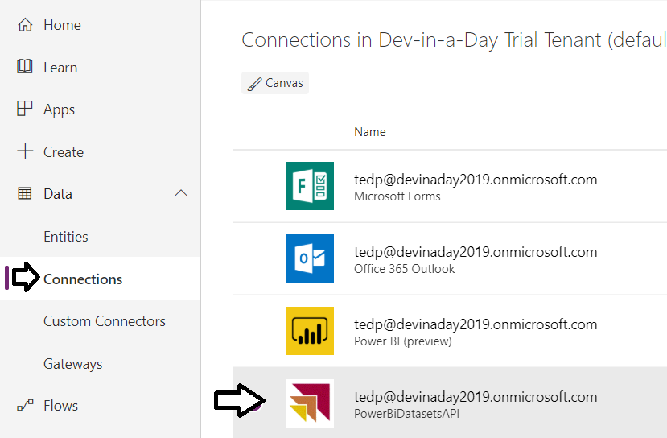

1. Import a canvas app to use the custom connector.
   1. Navigate to the Apps view of the PowerApps Maker portal.
   2. Click **Import package**.

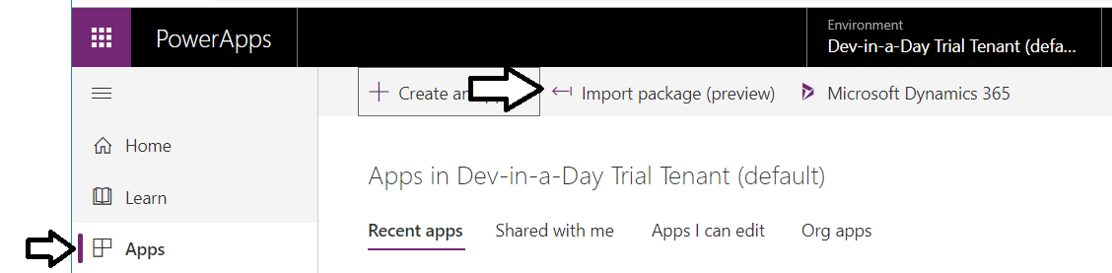

* 1. Click **Upload**.

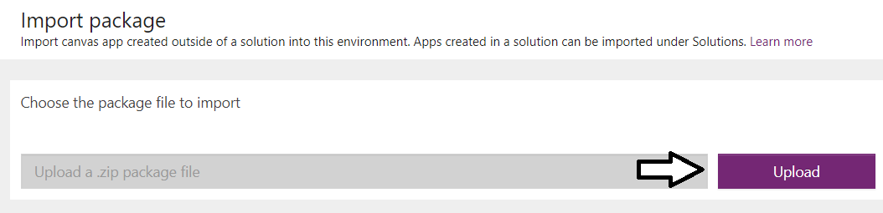

* 1. Select the file from the ZIP archive download named **PowerBIDatasetManager** and click **Open**.

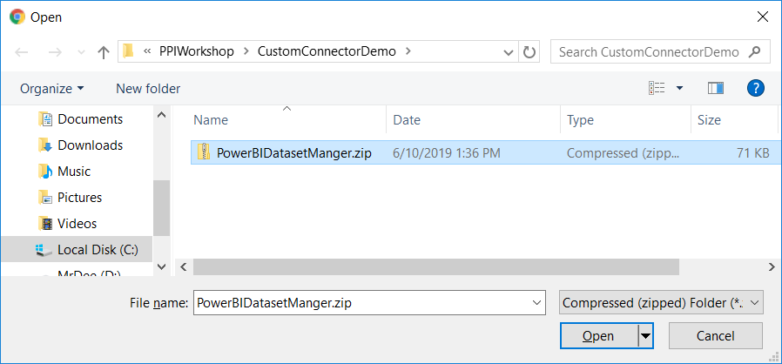

* 1. In the **Related resources** section, click Action for the **PowerBiDatasetAPI**.

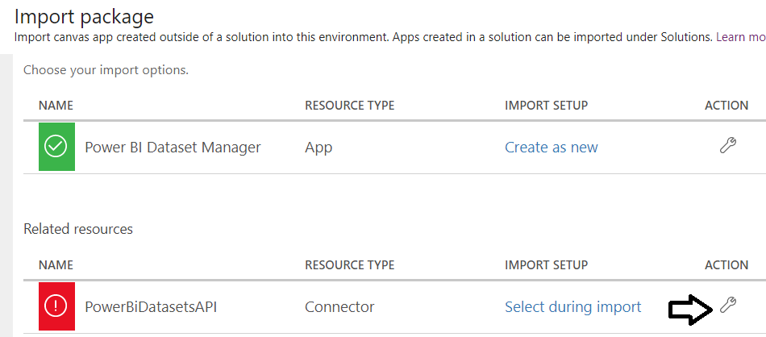

* 1. In the Setup pane, select **PowerBiDatasetAPI** and then click **Save**.

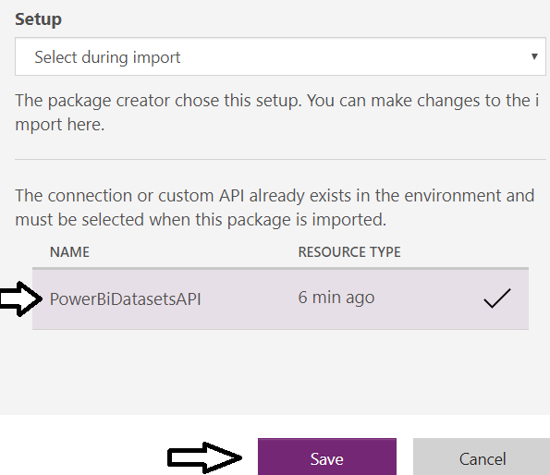

* 1. Click **Import** to import the new canvas app.

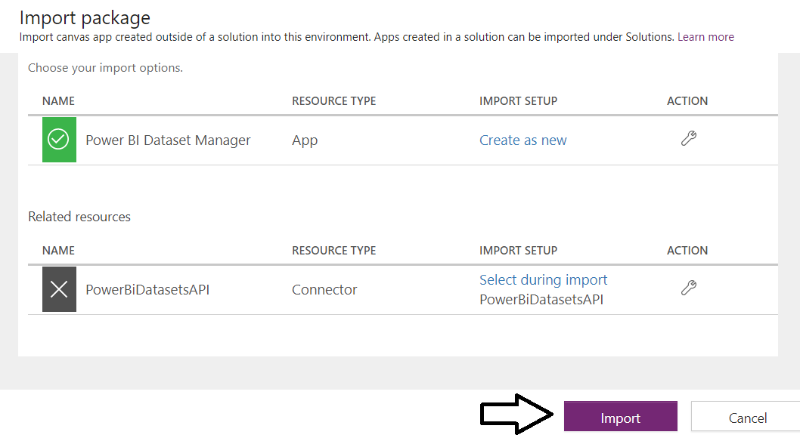

* 1. Open the app in edit mode.

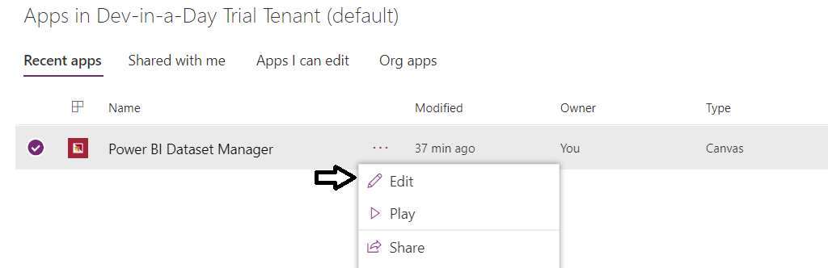

* 1. If prompted for consent, click **Allow**.

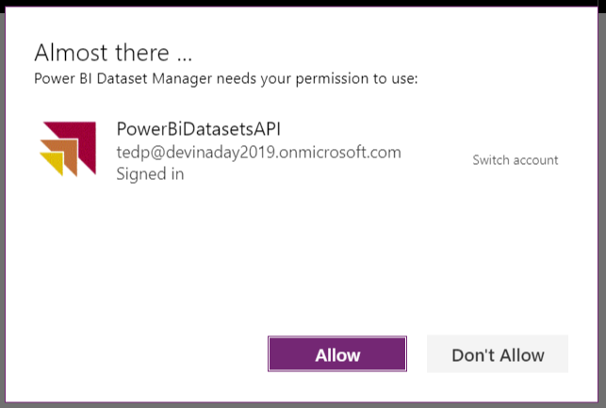

* 1. The app should populate the **WorkspaceScreen** with the Power BI app workspaces in your tenant.

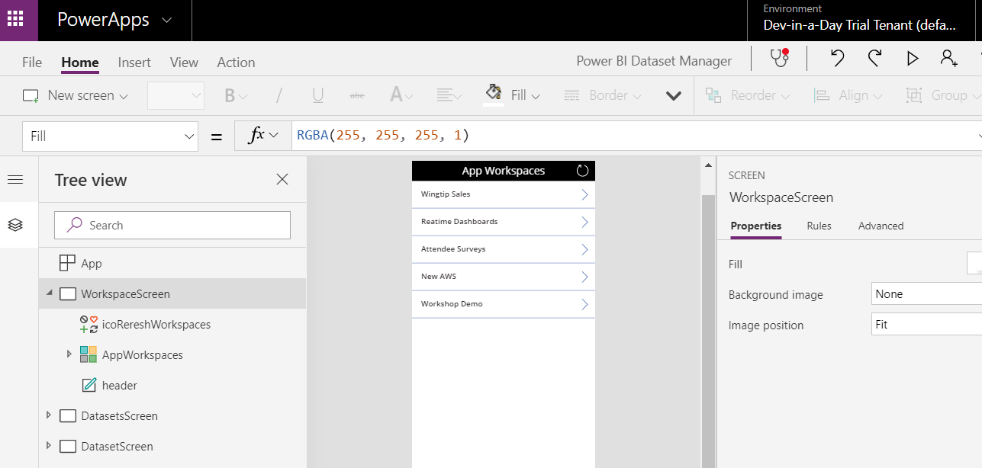

* 1. Start up the canvas app and navigate to a workspace.

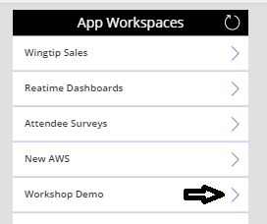

* 1. Click on one of the datasets in that workspace.

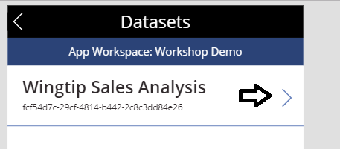

* 1. Inspect the dataset details and try to refresh the dataset

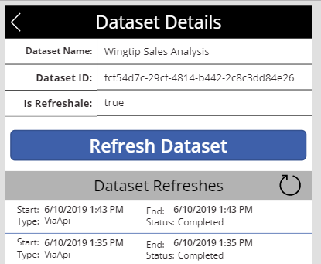

Play around with the canvas app and explore how it uses the custom connector..